Model:C1W-BJST-CTVT
PCB SIZE : 145.5*130*1.5 mm
LAYER : 2 layer
THROUGH HOLE：metallization

TOP
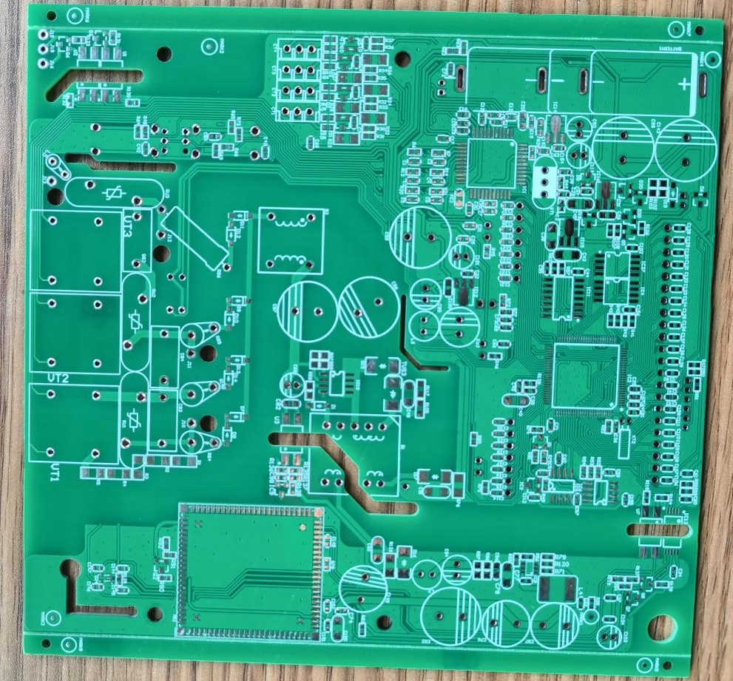
Bottom
