PCB SIZE :113.5*110mm

LAYER : 2 layers

THROUGH HOLE：Metalization

VERSION: C2Y-W255-GPRS-1

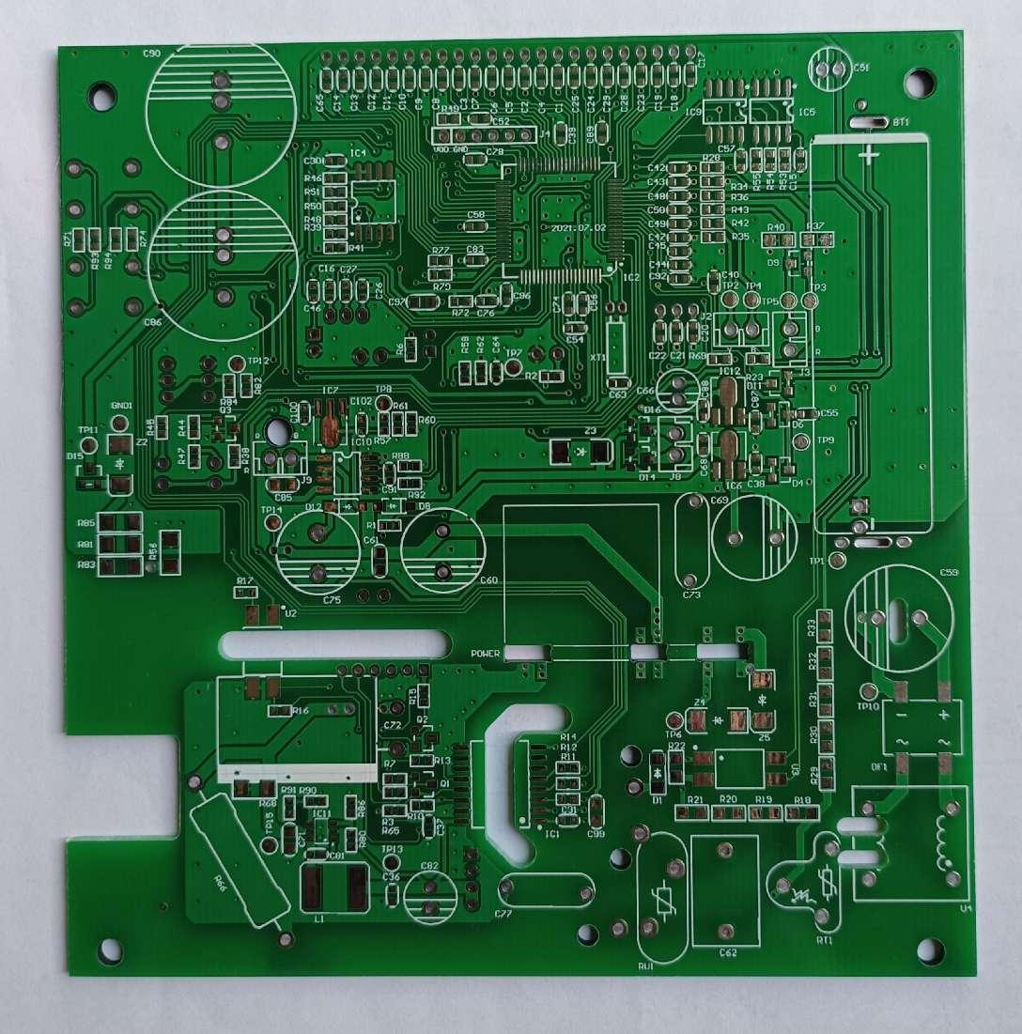

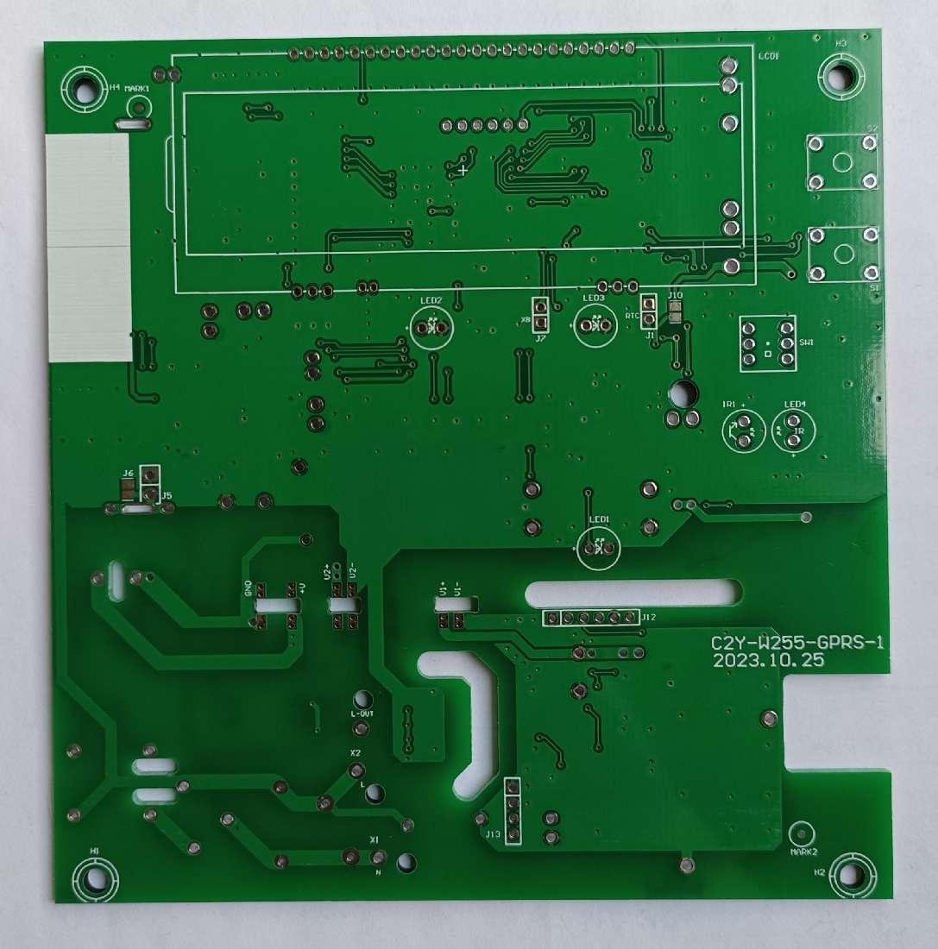

|  |  |  |  |  |  |  |  |  |  |  |  |
| --- | --- | --- | --- | --- | --- | --- | --- | --- | --- | --- | --- |
| **出货检验报告** | | | | | | | | | | | |
| **客户：** | | | **客户型号：C2Y-W255-GPRS-1** | | | | **编号：101100102306-00** | | | | |
| **订单号码： /** | | | **出货数量: /** | | | | **外观抽检标准：AQL=0.65 抽查数：20 PCS** | | | | |
| **生产周期： /** | | | **检验日期：2023.9.19** | | | | **检验员：杨如萍** | | | | |
|  |  |  |  |  |  |  |  |  |  |  |  |
| **检 查 项 目** | | | **要 求** | | **公差** | **检 测 结 果** | | **判 定** | | **备 注** | |
| 线路图形 | | | 依菲林底片 | | N/A | 吻合 | | ACC | |  | |
| 绿油/文字 | | | 依菲林底片 | | N/A | 吻合 | | ACC | |  | |
| 板材 | | | FR-4 1.6mm | | ±0.13 | 1.6mm | | ACC | |  | |
| 孔壁铜厚 | | | ＞18um | | / | 19um | | ACC | |  | |
| 镍/金厚度 | | | / | | Min | / | | / | |  | |
| 表面处理 | | | 喷锡 | | / | 喷锡 | | ACC | |  | |
| V-Cut余厚 | | | 0.53mm | | ±0.1 | 0.44mm | | ACC | |  | |
| 电测试 | | | 100%TEST | | N/A | PASS | | ACC | |  | |
| 外观检查 | | | 合格 | | / | 合格 | | ACC | |  | |
| 弯曲度 | | | ＜1.0% | | / | 0.70% | | ACC | |  | |
| UL marking | | | / | | / | / | | / | |  | |
|  |  |  |  |  |  |  |  |  |  |  |  |
| **试 验 项 目** | | | **要 求** | | | **检 测 结 果** | | **判 定** | | **备 注** | |
| 可焊性 | | | ＞95%上锡 | | | 上锡良好 | | ACC | |  | |
| 绿油附着力 | | | 3M胶纸测试，无绿油脱落 | | | No Peel Off | | ACC | |  | |
| 热冲击 | | | 纸质板：260°C×10S | | | No Graze | | ACC | |  | |
| 纤维料：288°C×10S | | |
|  |  |  |  |  |  |  |  |  |  |  |  |
| **孔 径 测 量 (mm)** | | | | | | | | | | | |
| 代号 | 要求 | 公差 | PTH or | 实测 | 判定 | 代号 | 要求 | 公差 | PTH or | 实测 | 判定 |
| NPTH | NPTH |
|  | 0.750 | ±0.075 | PTH | 0.785 | ACC |  | 3.200 | ±0.05 | NPTH | 3.200 | ACC |
|  | 0.800 | ±0.075 | PTH | 0.815 | ACC |  |  |  |  |  |  |
|  | 0.900 | ±0.075 | PTH | 0.920 | ACC |  |  |  |  |  |  |
|  | 1.000 | ±0.075 | PTH | 1.015 | ACC |  |  |  |  |  |  |
|  | 1.100 | ±0.075 | PTH | 1.135 | ACC |  |  |  |  |  |  |
|  | 1.300 | ±0.075 | PTH | 1.315 | ACC |  |  |  |  |  |  |
|  | 2.000 | ±0.05 | NPTH | 2.010 | ACC |  |  |  |  |  |  |
|  | | | | | | | | | | | |
| 代号 | 要 求 | | | 公 差 | | 实 测 | | | | 判 定 | |
|  | 200.00 | | | ±0.2 | | 200.06 | | | | ACC | |
|  | 119.73 | | | ±0.2 | | 119.79 | | | | ACC | |
|  |  | | |  | |  | | | |  | |
|  |  |  |  |  |  |  |  |  |  |  |  |
| **最终判定： 合格（Accept) □不合格（Reject)** | | | | | | | | | | | |
|  |  |  |  |  |  |  |  |  |  |  |  |