Model:C4W-W185-N51
PCB SIZE : 145*118.5*1.5mm
LAYER : 2 layer
THROUGH HOLE：metalization
TYPE: FR4
TOP
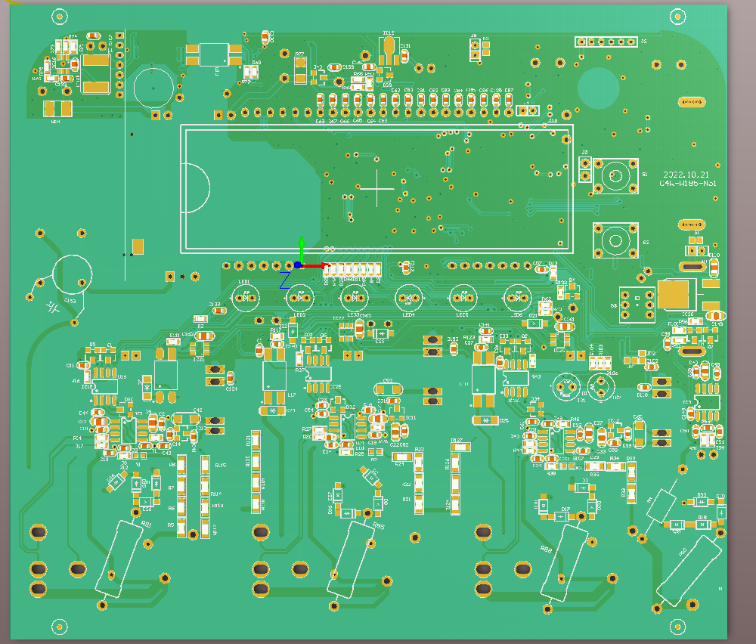
Bottom
