PF Impact Crusher: A Core Tool for Efficient Crushing, Helping Upgrade Material Processing Across Multiple Industries
Keywords: PF impact crusher, efficient crushing equipment, working principle of impact crusher, mining crushing equipment, construction waste processing equipment, application scenarios of impact crusher

Description: The PF impact crusher, with its high-efficiency crushing capability, uniform output particle size, and wide adaptability, has become a key piece of equipment in mining, construction waste recycling, road construction, and other fields. This article provides a detailed explanation of its working principle, core advantages, and application scenarios, helping enterprises make precise selection decisions.

image: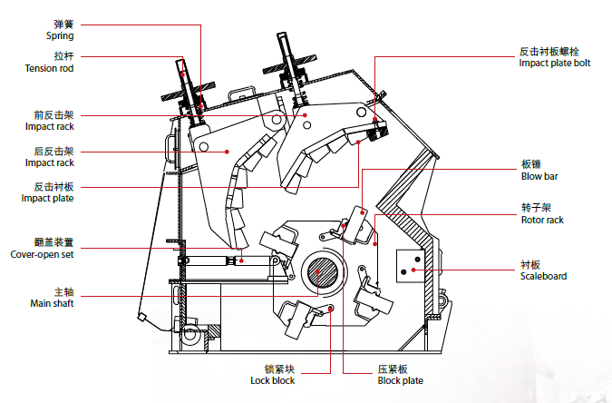
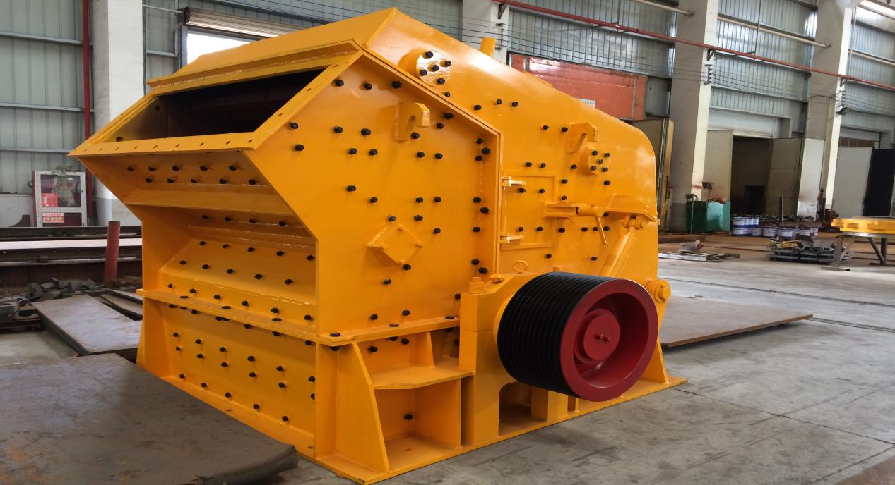
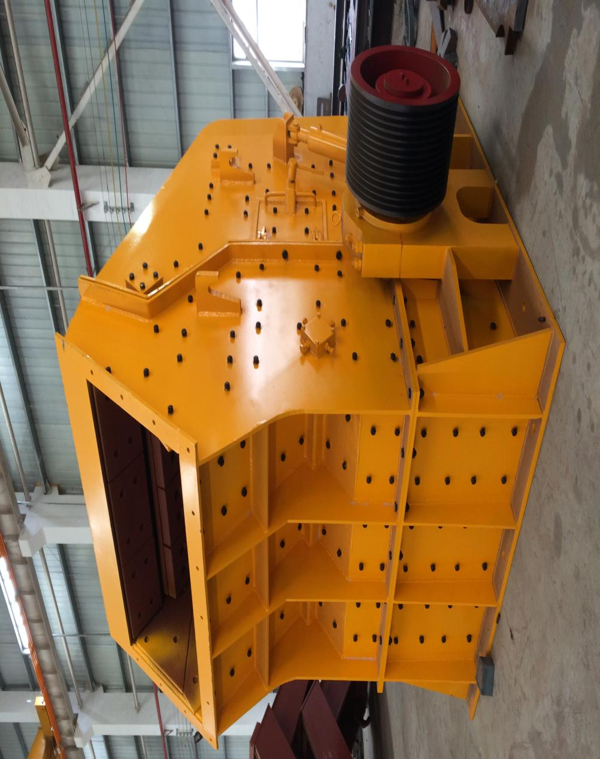

In fields such as mining, infrastructure construction, and construction waste recycling, material crushing is an indispensable core process, and the performance of crushing equipment directly determines processing efficiency, product quality, and overall cost. Among them, the PF impact crusher has become the preferred equipment for many companies due to its unique crushing principle, high operational efficiency, and wide adaptability. Today, let's take a comprehensive look at this 'crushing powerhouse' and see why it stands out in multiple industries.

一、Direct to the Core: The Working Principle of the PF Impact Crusher
The core crushing principle of the PF impact crusher is 'impact crushing,' which differs from traditional extrusion-type crushing equipment by being more efficient and flexible in its operation. Specifically, once the equipment starts, the motor drives the rotor to rotate at high speed through a coupling. The material enters the crushing chamber through the feed inlet and first collides at high speed with the hammers on the rotor, undergoing the initial crushing. The impacted material then rushes at high speed toward the impact plates on the walls of the crushing chamber, experiencing a second crushing. Subsequently, the rebounding material repeatedly collides and grinds with the hammers and other materials until it is crushed to the desired size, and is finally discharged through the outlet.

This 'multi-stage impact and mutual grinding' crushing method not only allows for more thorough material breakage but also ensures uniform product particle size and attractive shape, making it especially suitable for scenarios that require high-quality finished particle shapes, such as aggregate processing for road construction.

二、Advantages Fully Revealed: The Core Competitiveness of the PF Impact Crusher
Compared to other types of crushing equipment, the PF impact crusher has very prominent advantages, mainly reflected in the following aspects:

High crushing efficiency and large processing capacity: The high-speed rotation of the rotor generates strong impact force, capable of quickly crushing various medium-hard materials (such as granite, limestone, concrete blocks, etc.). A single machine can handle several tens to several hundred tons per hour, fully meeting the needs of large-scale operations.At the same time, the equipment's feed inlet is designed reasonably, accommodating larger-sized raw materials, reducing the need for preliminary processing, and further improving overall processing efficiency.

High-quality finished product with good particle shape: As mentioned earlier, impact crushing allows the material to break along natural fissures, resulting in a finished product with a cubic shape, low flakiness, and reasonable gradation. This advantage makes the PF impact crusher irreplaceable in infrastructure projects such as highways, high-speed railways, and bridges, where stringent requirements for aggregate quality are demanded.

Wide range of applications and strong compatibility: Whether it is primary ores such as granite, basalt, and iron ore in mining, concrete blocks and bricks in construction waste recycling, or various medium-hard materials in the chemical and building materials industries, the PF impact crusher can handle them with ease. In addition, by adjusting the gap between the impact plates and the hammers, the output particle size can be flexibly controlled to meet different processing requirements.

Simple structure and easy maintenance: The PF impact crusher has a compact overall structure, and its core components (such as the blow bars and impact plates) are designed in a modular fashion, making assembly and disassembly convenient. During routine maintenance, you only need to regularly check the wear of the blow bars and replace them in time, without complex disassembly procedures. This effectively reduces downtime and lowers maintenance costs. Additionally, the wear parts of the equipment are made of high-wear-resistant alloy materials, which have a longer service life, further enhancing the stability and cost-effectiveness of the equipment.
Energy-saving and environmentally friendly, in line with policy requirements: The new generation PF impact crusher is designed with a focus on energy conservation and environmental protection. By optimizing the crushing chamber structure and equipping it with noise reduction devices, it effectively reduces noise pollution during operation. At the same time, the equipment has good sealing performance, which can reduce dust leakage. When used with dust removal equipment, it enables green operation and meets current environmental policy requirements.

三、Application Scenario: The 'Place to Shine' for PF Counterattack Crushers
With the above advantages, the PF impact crusher has a wide range of applications, covering multiple key industries：

Mining Industry: In the mining and processing of granite, limestone, quartz, iron ore, and other minerals, the PF impact crusher can be used for coarse, medium, or fine crushing, providing qualified raw materials for subsequent grinding, sorting, and other processes. For example, in limestone mines, the material crushed by the PF impact crusher can be directly used as raw material for cement production or processed into construction aggregates.

Construction Waste Recycling Industry: With the advancement of policies for recycling construction waste, the PF impact crusher has become the core equipment for construction waste processing. It can crush concrete blocks, bricks, stones, and other materials from construction waste into recycled aggregates, which can be used to produce recycled concrete, recycled permeable bricks, road base layers, and more, achieving resource recycling of construction waste. This not only addresses environmental issues but also creates economic value.

Infrastructure Construction Industry: A large amount of high-quality aggregate is needed in the construction of infrastructure such as highways, railways, bridges, and airports. The PF impact crusher produces finished particles with good shape and reasonable gradation, which can be used for the production of asphalt concrete, cement concrete, and other mixtures, ensuring project quality. For example, in highway construction, aggregates for the subgrade and pavement are mostly processed using PF impact crushers.

Building Materials and Chemical Industries: In the building materials industry, PF impact crushers can be used to crush materials such as gypsum, talc, and limestone, providing raw materials for the production of products like tiles, boards, and coatings. In the chemical industry, they can be used to crush chemical raw materials such as gypsum and salt mines, meeting the requirements for subsequent processing.

四、Selection Recommendations: How to Choose the Right PF Impact Crusher?
When enterprises choose a PF impact crusher, they need to consider factors such as their own processing requirements and material characteristics comprehensively: First, clarify the type and hardness of the material (for example, granite is harder and requires a model with more wear-resistant blow bars); secondly, determine the required processing capacity and output particle size; and finally, consider factors such as the size of the worksite and environmental requirements to select the appropriate model and configuration. It is recommended to choose equipment produced by a reputable manufacturer to ensure quality and reliable after-sales service.

In short, the PF impact crusher plays a key role in various industries with its efficient, high-quality, and flexible crushing advantages. With the increasing demands for intelligent and environmentally friendly mining, the PF impact crusher is continuously being upgraded and iterated, evolving towards being smarter, more energy-efficient, and more effective. If you are looking for a crusher that is highly adaptable and cost-effective, the PF impact crusher is definitely worth considering.

