Ningbo Hangdi Electric Technology Co., Ltd.

Social Responsibility Report

Report date: December 20, 2023
Anaphora

This report is the first Corporate Social Responsibility Report publicly released by Ningbo Hangdi Electrical Technology Co., LTD. (hereinafter referred to as the "Company" or the "Company"), which is compiled in conjunction with the construction of the Company's social responsibility system in 2022. The Company guarantees that the information contained in this report does not contain any false records, or misleading statements, and takes responsibility for the authenticity and accuracy of its content.
Scope of report:
The organization scope of this report is Ningbo Hangdi Electrical Technology Co., LTD. This report describes the company's philosophy, system, measures taken, and performance achieved in terms of economic responsibility, social responsibility, and environmental responsibility during the period from January 1, 2022, to December 31, 2022.
Report release form:
The Company regularly releases a social responsibility report once a year, this report is in the form of a PDF electronic document on the company's website (www.hangdi.com) to the public, welcome to download and read and give valuable comments.
I. Company profile
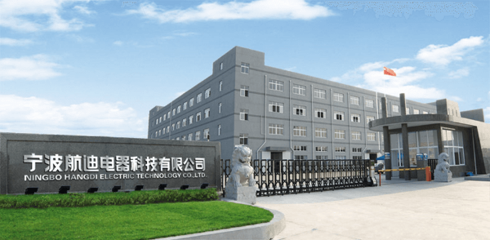
Ningbo Hangdi Electrical Technology Co., Ltd. was founded in 2000, located in Fuhai Town, Cixi City, south of Hangzhou Bay Bridge, and is a private backbone enterprise integrating product development, manufacturing, sales, and service. At present, the company covers an area of more than 80 acres, more than 300 employees, with all kinds of senior technical management personnel more than 50, specializing in the production of water fountains water purifiers, and other products. In recent years, the company has invested more than one billion yuan to establish 20 domestic first-class water dispenser assembly lines, and equipped with perfect inspection and testing equipment, water dispensers, water purifiers annual production capacity of more than 2 million units, in an an the water dispenser, tea bar machine, air fryer research, and development, production has a leading position in the industry.
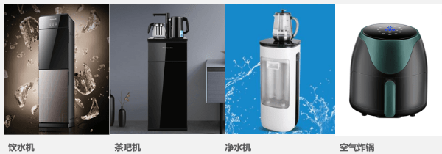
Professional guarantee quality, innovation guarantee development! In the fierce market competition, Hangdi people always adhere to the business philosophy of "win-win cooperation, pragmatic innovation" and constantly surpass themselves. The company's products have passed the national CCC, water-related approvals, and other certifications, and have been rated as "consumer trusted units" and "China well-known trademarks". At the same time, after years of development, the company has become a "high-tech enterprise" and "Ningbo Engineering Technology Center", and has obtained one invention patent, and dozens of utility model and appearance patents. The company has established long-term and stable cooperative relations with domestic and foreign customers such as Haier, Midea, Aucma, TCL, Konka, Meiling, Angel, etc. The products sell well all over the country, and are exported to more than 40 countries and regions such as Southeast Asia, Africa, the Middle East, Europe, and the United States, and are widely praised by all walks of life.
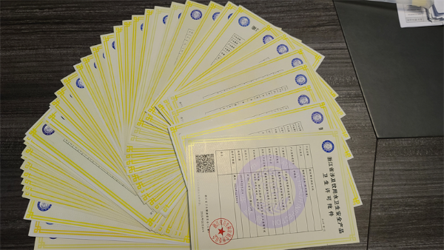
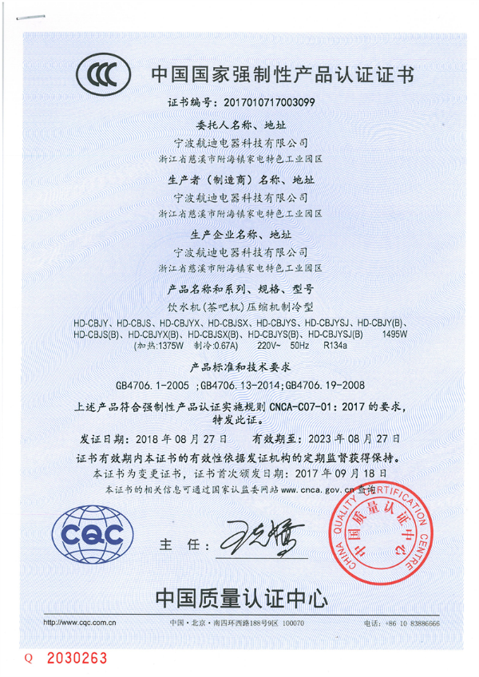
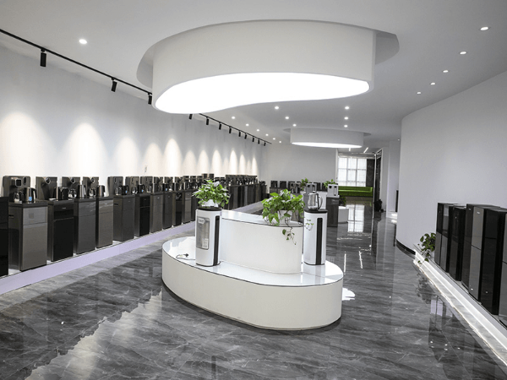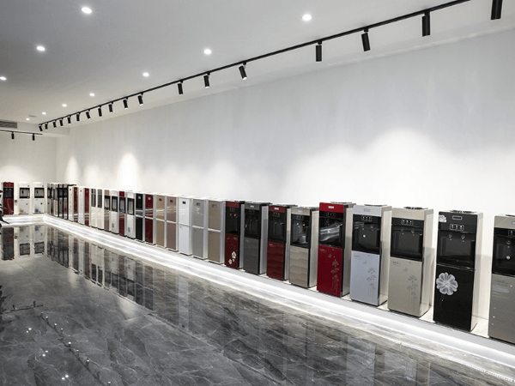
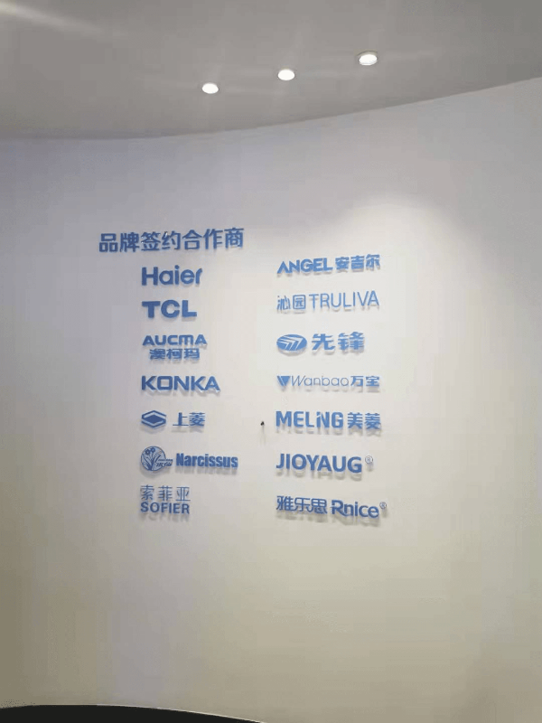
The company adheres to the purpose of "from excellent to excellent", and constantly improves the level of products in health, environmental protection, energy saving, and other aspects. It has always taken the concept of building a modern home that is fashionable, healthy, energy and convenient for human beings as its responsibility, continuous progress, innovation, and dedication to provide high-quality products and excellent service for customers at home and abroad, and is willing to work with friends at home and abroad to create brilliant!
Second, economic responsibility
1. Formulating development strategies
Based on the mission/vision and core values, the company is customer-oriented and market-oriented. Based on the analysis of internal and external resources and environment, the company combines the bottom-up information collection with the top-down decomposition of strategic objectives through the use of the company's sound strategic management system and development procedures, forecasts, estimates, choices and assumptions, and other methods to compile the company's strategic planning.
1. Organization guarantee
The company has set up the Strategy committee, the General Manager Office, and the functional planning group with the participation of the main functional departments to provide organizational assurance for the formulation and deployment of the company's strategy through reasonable division of labor, as shown in the following figure.
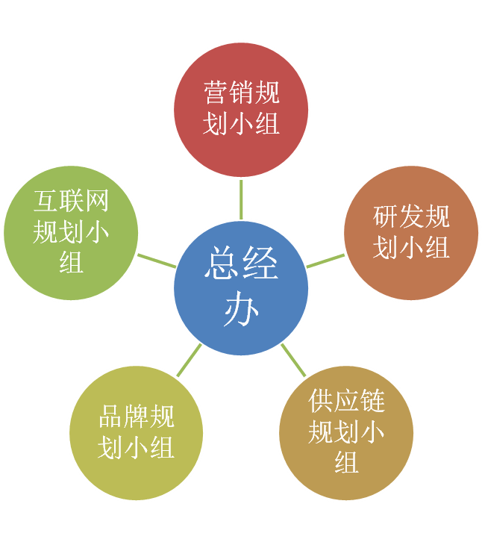
FIG. 2 Organizational structure chart of strategic management of Hangdi Electric
2. Process guarantee
The process of corporate strategy formulation is mainly divided into three stages: external environment (macro environment, overall industry environment, and industry competition environment), internal capability analysis, and strategy determination. Scientific and advanced analytical tools are adopted to confirm the company's development strategy through bottom-up and top-down repeated analysis and demonstration, while focusing on improving the level of corporate strategic management with the help of the external brain.
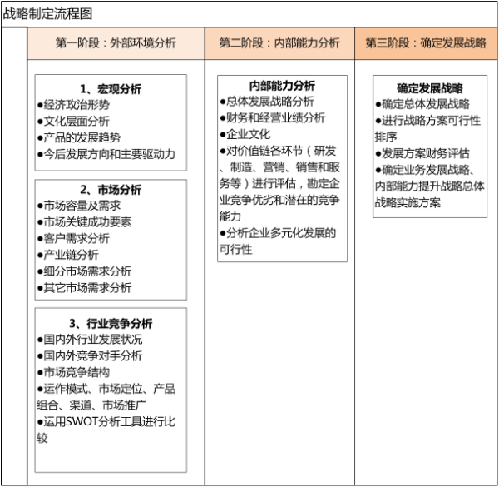
Figure 3 Strategy formulation phase diagram
3. Strategic planning cycle
The time interval of the company's strategic plan is divided into long-term and short-term. The time interval of each level and its determination basis are as follows:
① Time range of long-term strategic plan
Given the rapid development of the small home appliance industry, and the national, provincial, and municipal governments supporting industrial development plans, the company's long-term strategic planning cycle is generally set at 5 years. The main contents of the long-term strategic plan include analysis of macroeconomic and industry medium and long-term trends, analysis of internal resources and capabilities of enterprises, determination of organizational mission, description of development vision, formulation of medium and long-term development goals, operation mode, selection of strategic paths and action strategies (such as Market segmentation, product matrix, technological innovation, manufacturing layout, marketing strategy, etc.), optimize the allocation of key resources of the organization, organizational guarantee and evaluation mechanism for strategic actions.
The setting of the long-term strategic plan time interval is mainly based on industry planning, domestic and foreign market conditions, national industrial policies and regulations, and changes in consumption structure, and defines the development direction and goals of the company.
② Time range of short-term strategic plan
The short-term strategic plan time interval is 1 year, that is, the annual target, which is consistent with the traditional custom of financial accounting by "year" in our country. Under the established medium - and long-term strategic planning framework, the company develops short-term strategic planning based on the basic judgment of the annual internal and external business environment by the business cycle and the principle of step-by-step implementation. The contents mainly include a basic judgment of the short-term macro and industrial environment, a review of the internal business situation and resource capacity of the company, and the main principles and objectives of the annual business (including Revenue objectives, sales structure, capacity planning, operational efficiency indicators, etc.), major strategies and action plans, breakdown of key work plans, organizational promotion and evaluation mechanisms, etc.
The setting of the time interval of the short-term strategic plan is mainly based on timely and accurate responses to the challenges of rapid changes in the market. Through annual rolling revision, the company's long-term strategy is effectively combined with daily business work to ensure the realization of the company's annual objectives and the success of the overall strategy.
2. Long, medium, and short-term main strategic objectives
In the next few years, under the background of the new development pattern of the double cycle and the new normal of the Chinese economy, the company's opportunities and challenges coexist. Through the reform of the supply side, the company will complete the strategic upgrading of the brand and is committed to becoming an excellent enterprise in the manufacture of water dispensers. Under the guidance of the idea of promoting industrialization through informatization, the company will enhance the level of intelligent manufacturing of enterprises and continue to deeply farm in the subdivision industry of water dispensers. Strive to improve their core competitiveness and innovation ability, promote the digital transformation of the company, from excellent to excellent, the next 5 years sales exceeded 500 million, more than 1,000 direct stores, product sales covering 5 continents.
1. Long-term strategy
Sales strategy: By 2028, the company's sales will exceed 500 million yuan, with more than 1,000 direct stores and product sales covering 5 continents.
Technology innovation strategy: Advance product research and development according to customer needs; The output rate of new products is more than 50%, and the development of high-quality electric products with new functions can improve the profit margin.
Brand strategy: To create a "Hangdi Electrical Appliances" high-end brand, the formation of the high and low complete product line.
2. Short-term strategy
Sales will exceed 200 million yuan in 2024.
Strengthen the construction of the talent echelon, and by 2024, there will be no fault in talents and the company will form a talent magnetic field.
Continue to carry out innovation and technological transformation, ensure product advancement, increase production capacity, control costs, pay attention to the improvement of product quality, timely adjustment of product structure, propose broader program application, and improve product added value and application scenarios.
Invest no less than 4% of the operating income for research and development every year to ensure that the technical content of products is in the industry-leading position.
Third, social responsibility
(1) Be honest and law-abiding
The senior leaders follow the management philosophy of "operation according to law and integrity", and strictly abide by the Company Law, the Economic Law, the Contract Law, the Product Quality Law, the Production Safety Law, the Environmental Protection Law, the Labor Law and the relevant laws and regulations of the metal products industry, strengthen the legal knowledge training of employees, and cooperate with the government departments to carry out legal education activities. Encourage and commend the "positive energy" of employees, so that the style of integrity and law-abiding deeply in the consciousness and behavior of all employees of the company. The active default rate of the company's contracts is zero, it never defaults on bank loans, and overdue accounts receivable are reduced to a reasonable range. The company's senior and middle-level leaders have no record of violating laws and discipline, and the number of violations by employees is zero, establishing a good image of credit ethics in customers, users, the public, and society.
(2) Quality and safety
The company formulates the routine product production and operation control process, so that each link is strictly controlled and strictly checked to ensure that the production of each part meets the relevant requirements and ensures the quality of the final product. The company also uses the three-inspection system, that is, self-inspection, random inspection, and quality supervision team to strictly control product quality. Self-test includes product self-test and assembly self-test. Product self-test means that employees inspect the products produced by themselves according to the requirements of the drawings, make a judgment on whether they are qualified, and make relevant self-test records in the Self-test List. The modular production mode enables the key quality links of products to be exposed and controlled, thus ensuring quality and safety.
The company has passed the ISO9001 quality management system and standardized good behavior enterprise acceptance, strictly by the international quality management system, so that the quality of enterprise products has been strongly guaranteed, so that the enterprise "quality first, on-time production, on-time delivery" quality policy can be successfully implemented. Since the establishment of the factory, the company has never had major quality complaints, and the pass rate has reached 100% in the random inspections of quality and technology departments at all levels over the years.
(3) Employees' rights and interests
By identifying the needs of employees, the company creates a suitable and safe working environment, protects the rights and interests of employees, and enables employees to enjoy a safe workplace, reasonable compensation and benefits, equal development opportunities, and necessary support.
1. Manage according to law and create a comfortable working environment
The company earnestly implements the Labor Law, the Production Safety Law, and the Occupational Disease Prevention and Control Law, formulates the Production Safety Management System, the Occupational Health and Safety Management Measures, and the Labor protection Supplies Management Measures, adopts special protection for special types of work, and allocates necessary labor protection supplies. Set up a safety production leading group, through safety knowledge training, carry out safety competitions, strengthen the safety awareness of all staff, and reduce the accident rate. Given all kinds of safety conditions encountered in the production process, the health management Department has formulated detailed management regulations, operating procedures, and plans to carry out 6S safety checks on the workshop regularly and record safety hazards promptly.
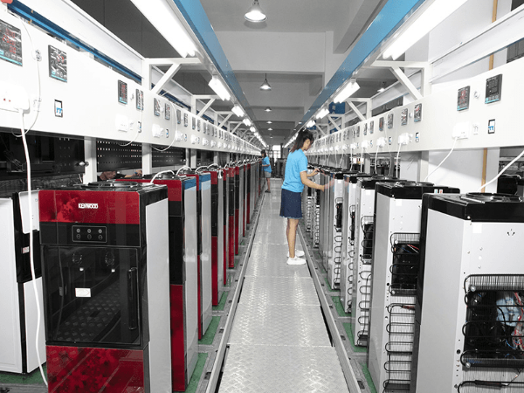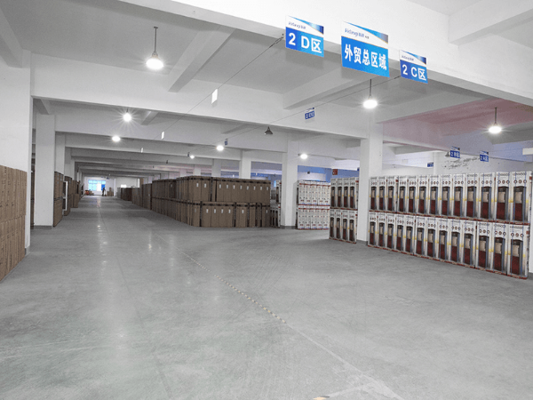
FIG. 5 Good workshop environment
The company refers to the requirements of ISO 14001 standard to identify environmental factors and hazards in the workplace and take appropriate protective measures. The company also holds a variety of activities every year to engage employees in improving the safety environment.
Table 2 Hazard Source Identification and prevention measures in the workplace
category | Sources of Danger and Hazards | Precautionary measures
Safety | Environmental impact due to exhaust gases, wastewater, solid waste | 1. Waste gas and wastewater are discharged after treatment  2. Solid waste shall be disposed of by professional institutions;
 | Human and financial damage caused by natural disasters such as typhoons and heavy rains | 1. Strengthen publicity and education on the knowledge of anti-Taiwan, anti-Taiwan, and self-help;  2. Take emergency measures to minimize the impact of typhoons and rainstorms
 | Elevator control fails, doors do not open, or fall rapidly, resulting in trapped or casualties | 1. Regularly invite a third party to conduct annual inspections and formulate a regular inspection system  2. Formulate emergency plans and conduct regular training and education for employees
 | Damage to electrical insulation, resulting in leakage, etc., may lead to electric shock or fire damage | 1. Carry out annual inspections according to internal and external inspection requirements, and improve the safety management system  2. In the process of design, installation, and use of power distribution cabinets and air compressors, etc., strictly follow the relevant national regulations, and do a good job of relevant protection and publicity reminders
 | Damage to human skin and respiratory tract caused by dust in the production workshop | 1. Purchase special labor protection equipment for protection;  2. Conduct regular health examinations for employees
 | Damage to plants, products, equipment, personnel, etc. caused by burst and leaking water pipes | Close the main valve at the end of the day, and make regular inspections at the end of the day
 | Injuries caused by equipment failure or human error | 1. Carry out regular maintenance and maintenance of equipment, and formulate a regular inspection system;  2. Implement the management and responsibility of the equipment, and do a good job in pre-job training
 | Injuries caused by overloading, speeding, or illegal operation of vehicles and forklifts in the factory area | 1. Formulate forklift operation and use procedures and safety management systems, and strictly implement them  2. Do a good job of speed limit/safety signs in a conspicuous place in the factory area to remind you
 | Workplace chaos, blocked passageways, poor lighting, etc., cause injury or property damage | 1. Regularly inspect and rectify the on-site 5S  2. Turn on the lights when working, and repair them in time if they are found to be not bright
 | Incorrect posture and method during the handling process lead to injury to personnel and goods | 1. According to the weight and shape of the item, use the correct method to carry it  2. Do not overload the handling of items
 | Cuts and other mechanical injuries to the human body caused by semi-finished burrs in the working process | 1. Wear labor protection equipment;  2. Equipped with a first-aid kit at the designated position of the workshop
 | Fire hydrants and fire extinguishers are aging or will not be used | 1. Regularly inspect fire hydrants and fire extinguishers  2. Conduct fire safety knowledge training and fire emergency evacuation drills for employees
 | Fire injuries caused by smoking on the factory premises | 1. Formulate a safety production management system;  2. Do not smoke within the area not specified in the factory's
public health | Domestic waste, solid waste, etc. will affect the health of employees and the surrounding environment | Adhere to the principle of "prevention first, prevention and treatment combined" for public health work;
 |  | Waste is managed separately and comprehensively to reduce the worries of employees and the community
2, prevention first, develop a variety of emergency plans
Hangdi Electric has set up a safety production leading group, established a rapid response mechanism, inspected and evaluated safety production management no less than twice a month, found problems, promptly required responsible units to rectify, and the safety production leading group to track and verify. Under the production safety leading group, an emergency response team is set up to organize training and exercises regularly, evaluate the effect of the exercises, rectify the problems existing in the exercises, improve the ability of employees to deal with dangerous situations or emergencies in production and implement safety education and training for all employees to strengthen their safety awareness.
Given possible security risks, the company has formulated emergency plans, such as "Typhoon emergency plan", "fire emergency plan", "environmental emergency plan" and other emergency plans, giving full play to the role of the emergency team, protecting the interests of employees and avoid production due to accidents, and meet the needs of customers promptly.
The company conducts surveys and statistical analysis through questionnaires, symposia, performance interviews, exit interviews, etc., to determine the key factors affecting the rights and interests, satisfaction, and enthusiasm of different employees, and to provide targeted and personalized support for employees. See Key Factors affecting employee satisfaction and personalized support measures of the company.
Table 3 Key factors affecting employee satisfaction and the company's personalized support measures
Employee classification | Key factors | Possibly  effect | Personalized needs | Targeted and individualized support measures
Top management | Salary, benefits, promotion opportunities, enterprise development, honors and achievements, corporate culture, etc | Loyalty, work performance, sense of achievement, dedication, etc | Ability improvement, job security, value realization, social recognition | Provide challenging work, project responsibility system, salary incentive, cultural integration, organizational training, advanced evaluation; Send overseas training and obtain MBA/EMBA degree, etc
Technical personnel | Salary, benefits, training and development, a certain amount of free space, etc | A sense of belonging, work potential, etc | Xi growth, work remuneration, and social recognition | Help design career planning, provide forward-looking training, provide training within the company, pay close attention to the promotion of professional and technical qualifications, improve the environment of office conditions and living quarters, build activity centers, rent courts, etc., provide competitive salary and generous benefits, send out training, professional title evaluation, and flexible working hours
Salespeople | Salary, benefits, training and development, etc | Satisfaction, work motivation, work quality, work passion, attrition rate, etc | Work remuneration and social recognition, job support, and Xi's growth | Provide attractive salary, rich employee benefits and holiday benefits, equipped with technical service personnel, provide new product knowledge training, customer production process analysis and product demand analysis, marketing management, negotiation strategies and skills, business etiquette, and other professional knowledge training
The Department also pays special attention to the needs of some special groups, such as the working environment, working hours, working intensity, long-term career development and equal opportunities for female employees; We should pay more attention to the characteristics of more and more post-80s and post-90s groups, formulate career plans for them, clarify development channels, carry out mentoring and special training, give higher work goals, and improve their business skills and individual qualities; For employees with family difficulties, the company provides strong help and support through the foundation, and the chairman personally contacts high-quality medical resources and educational resources, treating employees as relatives and constantly enhancing their sense of belonging.
The company through a variety of ways, such as National Day, New Year's Day party, skills competition, sports and sports activities, enriched the work and spare time life of employees, constructed a harmonious working environment, also organized the Xingyi City Zerong Town Anzhang Central Primary school student dormitory facilities and equipment donations, stimulate staff love, enthusiasm, and creativity, promote the harmonious development of the company. The company has also built reading rooms, staff activity rooms, and other entertainment facilities to meet the multi-level needs of employees so that employees can truly feel the happiness and warmth brought by the Hangdi Electric family.
Senior leaders of the company investigate and understand the opinions and suggestions of employees through Dingding, the WeChat platform, rationalization suggestions, employee satisfaction surveys, employee symposiums, participation in department regular meetings at the grassroots level, entertainment activities, employee emails, lunch meetings, and other forms to obtain employee satisfaction information. The administration department is responsible for tracking and supervising the clear problems and requires all relevant functional departments to deal with them within the specified time. Senior leaders pay attention to understanding the situation on the spot and make timely and positive feedback and processing within the promised time.
For example, in the production staff symposium, some employees reflected that because of seasonal differences in production and the process differences between male and female assembly operators, the salary level of employees fell, the loss of workers was serious, and it was difficult to recruit skilled workers when busy, affecting the production schedule. After understanding, the general manager put forward on the spot to change the production mode and improve the production environment, to ensure the income level and work stability of employees, and significantly improve the stability of the staff.
(4) Public welfare support
The company emphasizes corporate social responsibility and sincere return to society. The general manager attaches great importance to the cause of public welfare support, vigorously advocates and sets an example, and the leaders of the company will also make unremitting efforts to develop public welfare undertakings with the continuous development of the enterprise. The company plans the cost of public welfare support and the direction of public welfare support every year by the corporate strategy.
Company public welfare donations
Time | Accepted units | Supporting Content | Amount (10,000 yuan)
2019/6/19 | Cixi Charity Federation | Rice bucket land to build Huimin Building | 10
2019/5/14 | Cixi Charity Federation | Charitable donations | 3

(5) Social honors
Table 4 In the past three years, the company has won honors (above the municipal level).
Name of the award | Awarding department | Time of award | Award description
National high-tech enterprise | Ningbo Science and Technology Bureau, Finance Bureau, Taxation Bureau | 2023 years
Ningbo Enterprise Engineering Technology Center | Ningbo Science and Technology Bureau | 2022 years
Ningbo innovative small and medium-sized enterprises | Ningbo Municipal Bureau of Economy and Information Technology | 2022
4. Environmental responsibility
The company adheres to the environmental protection policy of "full participation, implementation of management, pioneering and innovative, factory environmental protection, pollution reduction, and compliance with laws and regulations", and continuously improves technology and technology, strengthens management, reduces the generation of various wastes, and ensures that all kinds of pollutants are discharged up to standards. Efficient use of resources, and through strengthening environmental protection training, ensure that every employee is aware of the impact of daily work and life behaviors on the environment.
(1) Environmental protection
The company's products and production and operation processes have little adverse impact on environmental pollution and social risks, but the company still attaches great importance to environmental impact control, strictly implements relevant national laws and regulations, and promulgates and implements the ".Emergency Response Plan" and other systems and management methods, organize and sign the safety management target responsibility letter every year, establish a safety early warning mechanism and safety accident emergency response mechanism, regularly carry out fire drills and emergency drills every year to achieve environmental and safety and health goals, and at the same time, the company has formulated an energy-saving management system and adopted energy-saving equipment, and formulated a resource recycling system to recycle the available resources. The company's environment, safety, energy consumption and other measurement indicators, methods, and control processes are shown in the following table.
Table 5 Methods for measuring and controlling public responsibility indicators
project | Impact metrics | target | Process control measures | measurement  way | charge  department
environmental protection | exhaust gas | National standards | Implement national standards | Environmental Protection Agency monitoring | General Manager's Office
 | wastewater
 | Solid waste | 100% processed
 | noise | National standards | Noise management regulations provide for the issuance of labor protection equipment
Energy consumption | Electricity, water | Energy consumption is decreasing year by year | Adopt energy-saving equipment and promote energy-saving products | statistics  analysis | Department of Health Management
Resource utilization | water resources | Recycling | Water circulation system |  | General Manager's Office
 | Additional Resources: | Eliminate waste and make the most of resources | Implement office automation and implement a "fixed cost budget" system
Safety | Company property and employee life safety | There are zero major safety accidents, and the safety accident rate is controlled at 3‰ | Pre-job training, implementation of safety production management system, operation procedures on the wall, implementation of 6S self-inspection and supervision, fire fighting, escape Xi, employee injury insurance and accident insurance, distribution of labor protection equipment |  | Safety production management team
Product Safety | Product Quality | There were no casualties due to the use of the company's products | The product design is implemented in accordance with relevant international and national standards, the product standards of the enterprise are formulated according to the first two standards, and the quality management system is implemented. | Quality analysis meeting  New product appraisal meeting | Quality Control Department
Public safety | Greening, water quality, sanitation | Green and low-carbon factories | Three waste management regulations, 6S management | daily  examine | General Manager's Office

(2) Saving resources
1. Energy consumption and utilization
The company's comprehensive energy consumption has been declining year by year in the past three years, and noise, exhaust gas and wastewater are all discharged。
Table 6 Discharge of three wastes
Test items |  | standard | Measured
 |  |  | 2021 | 2022 | 2023
noises |  | ≤65dB | 56 | 55 | 55
exhaust gas | SO2 | ＜0.4mg/m3 | not | not | not
 | TSP | ＜1.0mg/m3 | not | not | not
wastewater | pH | 6-9 | passing | passing | passing
 | CODcr | ≤100mg/L | passing | passing | passing

