**Ningbo Hangdi Electric Technology Co., Ltd.**

**Quality integrity report**

**Report date: December 18, 2023**

**anaphora**

**This report is the "Enterprise Quality and Integrity Report" publicly released by Ningbo Hangdi Electrical Technology Co., LTD. (hereinafter referred to as the "Company" or the "Company"). It is compiled according to the provisions of the national standard of the People's Republic of China GB/T 29467-2012 "Implementation Standards for Enterprise Quality and Credit Management" and GB/T 31870-2015 "Guidelines for the preparation of Enterprise Quality Credit Reports", combined with the construction of the company's quality and credit system in 2022. The Company guarantees that the information contained in this report does not contain any false records, misleading statements, and takes responsibility for the authenticity and accuracy of its content.**

**Scope of report:**

**The organization scope of this report is Ningbo Hangdi Electrical Technology Co., LTD. This report describes the company's philosophy, system, measures taken and performance achieved in quality management, product quality responsibility and quality integrity management during the period from January 1, 2022 to December 31, 2022.**

**Report release form:**

**The company regularly releases the quality credit report once a year, this report in the form of PDF electronic document on the company's website (www.hangdi.com) to the public, welcome to download and read and give valuable comments.****I. Company profile**

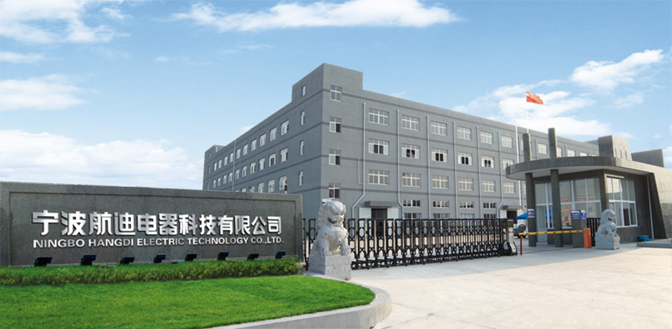

**Ningbo Hangdi Electrical Technology Co., Ltd. was founded in 2000, located in Fuhai Town, Cixi City, south of Hangzhou Bay Bridge, is a private backbone enterprise integrating product development, manufacturing, sales and service. At present, the company covers an area of more than 80 acres, more than 300 employees, with all kinds of senior technical management personnel more than 50, specializing in the production of water fountains and water purifiers and other products. In recent years, the company has invested more than one billion yuan to establish 20 domestic first-class water dispenser assembly line, and equipped with perfect inspection and testing equipment, water dispenser, water purifier annual production capacity of more than 2 million units, in the water dispenser, tea bar machine, air fryer research and development, production has a leading position in the industry.**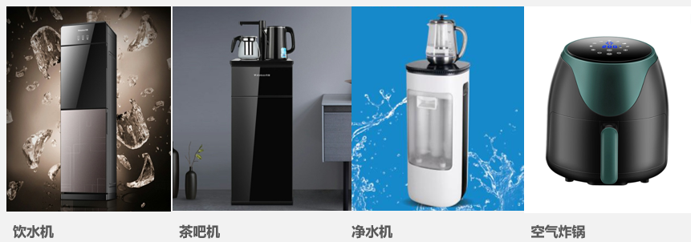

**Professional guarantee quality, innovation guarantee development! In the fierce market competition, Hangdi people always adhere to the business philosophy of "win-win cooperation, pragmatic innovation" and constantly surpass themselves. The company's products have passed the national CCC, water-related approvals and other certifications, and have been rated as "consumer trusted units" and "China well-known trademarks". At the same time, after years of development, the company has become a "high-tech enterprise" and "Ningbo Engineering Technology Center", and has obtained one invention patent, dozens of utility model and appearance patents. The company has established long-term and stable cooperative relations with domestic and foreign customers such as Haier, Midea, Aucma, TCL, Konka, Meiling, Angel, etc. The products sell well all over the country, and are exported to more than 40 countries and regions such as Southeast Asia, Africa, the Middle East, Europe and the United States, and are widely praised by all walks of life.**

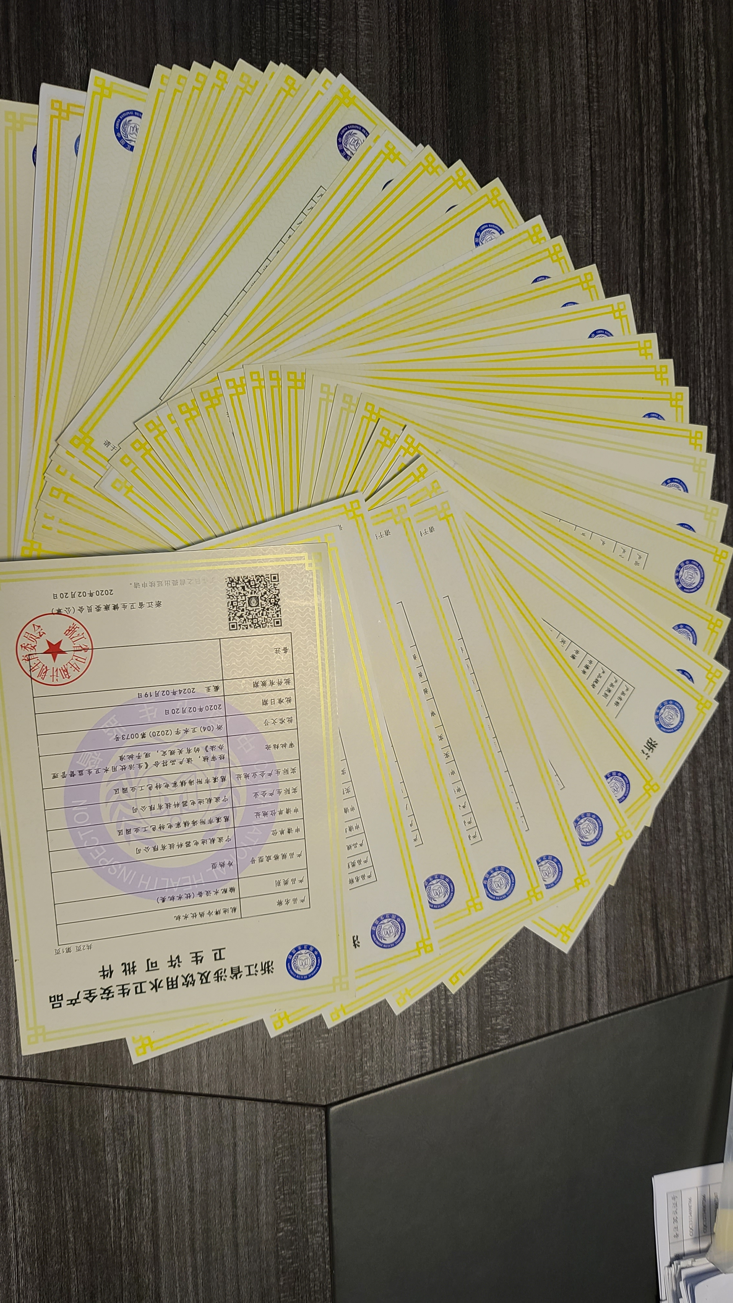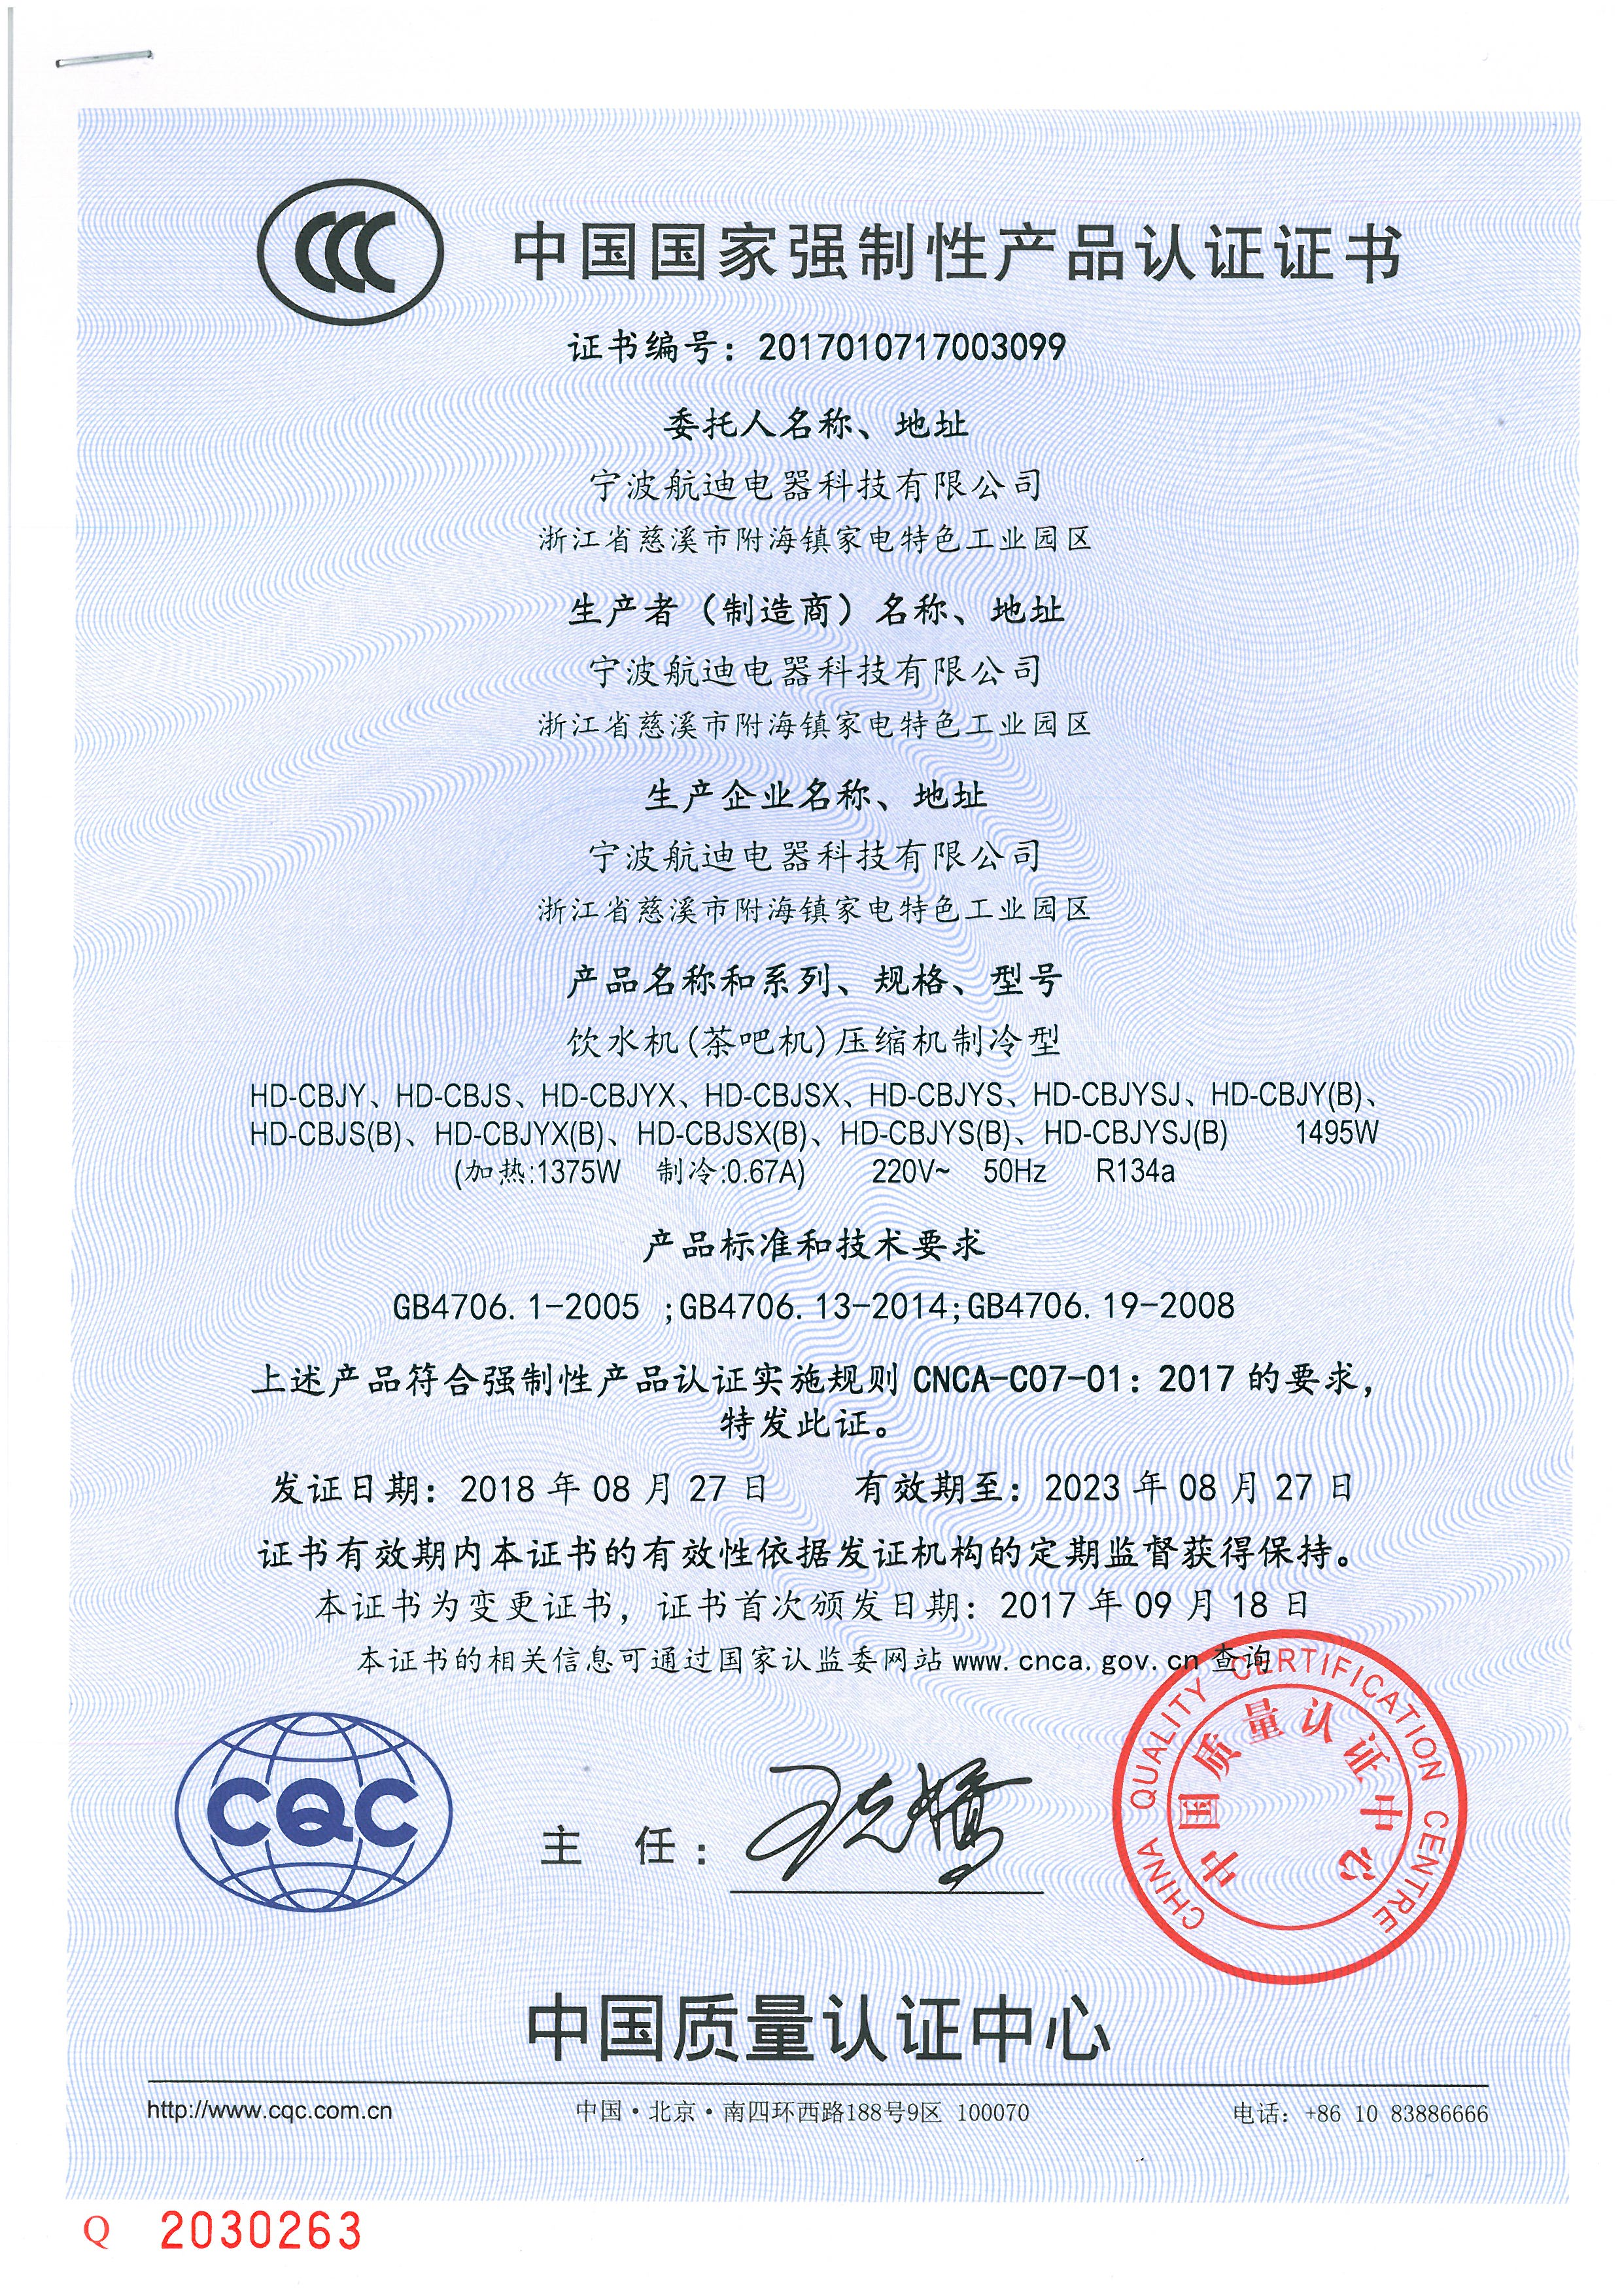

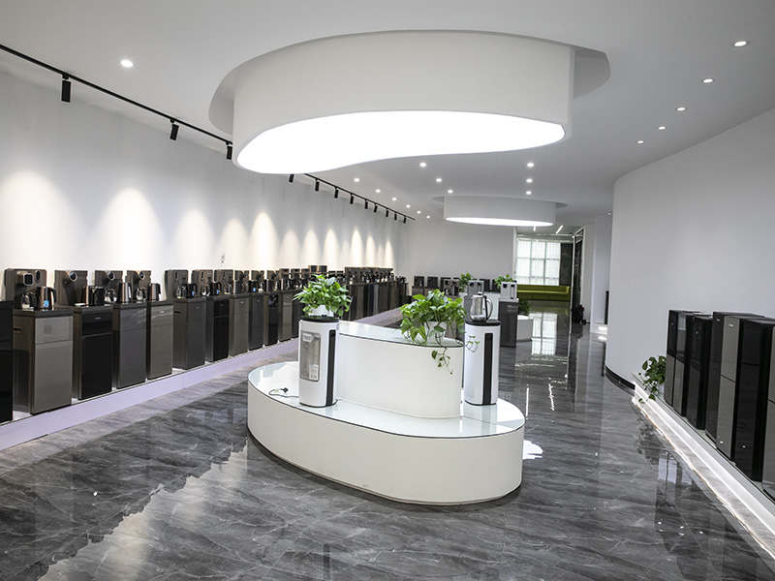 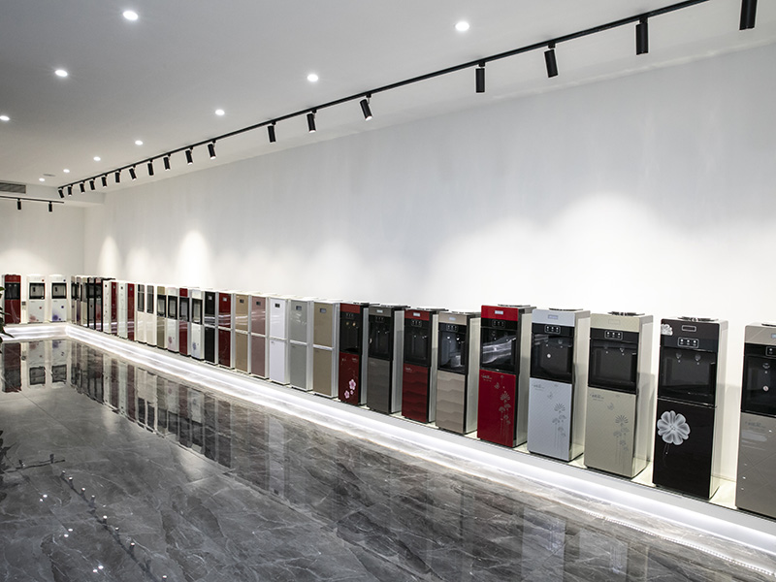

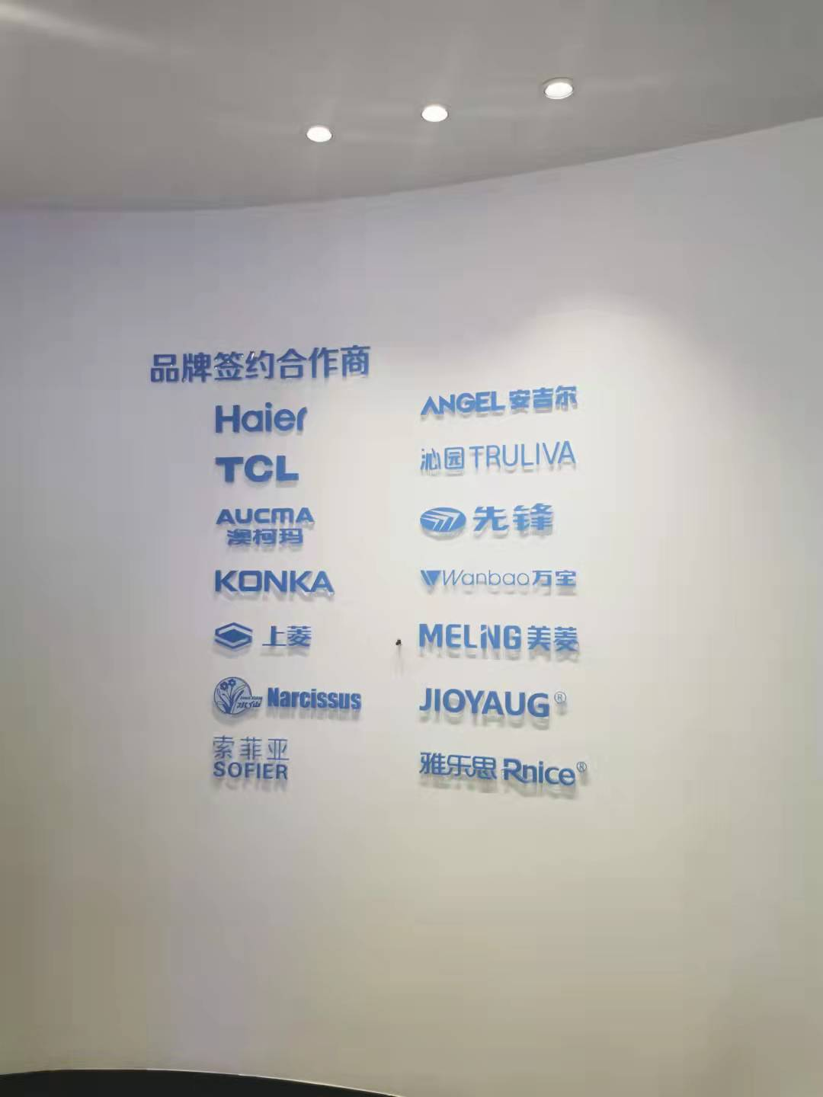

**The company adheres to the purpose of "from excellent to excellent", and constantly improves the level of products in health, environmental protection, energy saving and other aspects. It has always taken the concept of building a modern home that is fashionable, healthy, energy saving and convenient for human beings as its own responsibility, continuous progress, innovation, and dedication to provide high-quality products and excellent service for customers at home and abroad, and is willing to work with friends at home and abroad to create brilliant!**

**Second, enterprise quality concept**

**Hangdi Electrical company since its inception, is committed to creating high-quality products, the product quality as an important cornerstone of enterprise survival and development, the company through the ISO9001 quality management system, strictly in accordance with the quality management system implementation, so that the quality of enterprise products has been a strong guarantee, so that the enterprise "quality first, customer first; Green environmental protection, continuous improvement "quality policy has been successfully implemented. In order to fundamentally strengthen quality management and improve the quality of the company's operations, the company takes the introduction of performance mode as an opportunity to implement total quality management, use FMEA, SPC and other quality statistical tools, through internal audit, self-evaluation, third-party audit or evaluation, QCC quality control circle activities, and constantly look for improvement opportunities and continuous improvement ways to achieve excellent performance. Since the establishment of the factory, the company has never had major quality complaints, and in the random inspections of quality research and development departments at all levels over the years, the pass rate has reached 100%.**

**Table 1 Corporate culture and quality culture of Ningbo Hangdi Electrical Technology Co., LTD**

| **Projects** | **Contents** |
| --- | --- |
| **mission** | **Continuously improve the level of products in health, environmental protection, energy saving, etc., and always take the construction of human fashion, health, energy saving, convenient modern home concept as its own responsibility** |
| **vision** | **To be the world's best supplier of water dispensers, providing customers with the best service and quality** |
| **Core Values** | **Win-win cooperation, pragmatic innovation** |
| **Business purpose** | **Develop employees, achieve customers, return shareholders, and strengthen the country** |
| **Business Ideas** | **Integrity, pragmatism, dedication and innovation** |
| **Quality policy** | **Quality first, customer first, green environmental protection, continuous improvement** |
| **Environmental, occupational health and safety policy** | **Full participation, implementation of management, pioneering and innovative, environmental protection, pollution reduction, compliance with laws and regulations** |
| **Quality and integrity policy** | **Integrity management, careful design, selection of suppliers, fine workmanship, continuous improvement** |

**Third, enterprise quality management**

**(1) Quality management organization**

**In line with the high importance of product quality, the company has established a quality responsible system, formulated the inspection standards of each material, component and product, and each performs its duties, communicates with each other, and strengthens the control of product quality from the process of research and development, procurement, production and so on.**

** The general manager and senior management team -- responsible for the allocation of total quality management resources, the promotion of all staff awareness, and the implementation of the quality concept to all staff;**

** General Manager -- Responsible for establishing, monitoring and improving the company's integrated management system, administrative logistics and external relations;**

** Purchasing Department -- responsible for supplier development, supplier capability improvement, to ensure the quality of outsourced and outsourced parts;**

** R&D Department -- responsible for new product research and development, testing, internal commissioned testing;**

** Sales Department -- responsible for collecting domestic and foreign customers market complaints and product quality problems, and feedbacks to relevant departments;**

** Production Management Department -- responsible for the formulation and implementation of production plan and the whole process of product manufacturing;**

** Quality Control Department -- to carry out total quality management, responsible for organizing the planning of product realization process and the preparation of quality plans, controlling the company's production and service provision process, and constantly improving the company's overall quality management level; Responsible for promoting the implementation of the company's quality strategy, improving product quality and process quality indicators, and implementing quality improvement work.**

**At the same time, the company set up a chief quality officer, determine the responsibilities and authority of the chief quality officer, and implement a vote on quality, otherwise, comprehensively establish the company's quality culture.**

**Due to the importance of product and service quality and safety, the general manager of the company performed the following duties:**

**1) Participate in the formulation, review and determination of quality strategy;**

**2) Personally participate in monthly quality meetings;**

**3) Participate in major product quality review and quality improvement activities;**

**4) Participate in quality recognition activities and award QCC activities;**

**5) Participate in quality Month activities and popularize quality and safety education;**

**6) Establish the chief quality officer system and clarify the functions and powers of CQO;**

**7) Establish a clear quality accident accountability system and quality safety traceability system.**

**(2) Quality management system**

**The company introduced ISO9001 quality management system, "quality first, customer first; Green environmental protection, continuous improvement "as the quality policy, around the design, development and production process of water fountains, air fryers series products, the company according to GB/T 19001-2016" quality management system requirements "to establish a quality management system, the formation of quality manuals, procedure documents and other quality documents, to implement and maintain, and continue to improve the effectiveness.**

**1. Quality management system policy and objectives**

**The introduction of ISO 9001 quality management system, adhere to the "development of employees, achievements of customers, returns to shareholders, strong country" business purposes, to the introduction of excellent performance management model, the implementation of total quality management. Adhere to the "quality first, customer first; Green environmental protection, continuous improvement "quality policy, the company's quality management system from continuous improvement, to the pursuit of excellence, the establishment of the company's strategy as the core, GB/T19580 excellent performance model as the framework of the integrated total quality management system. To meet the requirements of customers, employees, suppliers, society and partners, we have established corresponding strategic planning and quality objectives at all levels of the company. Based on the company's performance appraisal system, quality appraisal KPI and quality accountability system have been established.**

**2. Quality education**

**In the process of system operation, the company uses various scientific and effective methods to measure, analyze and improve, and the system method based on PDCA continues to improve. The company uses a variety of tools to improve the performance of various departments and levels, and adopts benchmarking comparison and learning methods to constantly revise personal work ideas and methods to ensure the realization of personal and corporate overall goals. The company actively communicates with the outside world and invites experts to conduct special training for the company's employees. The company regularly carries out quality education for employees at all levels and conducts special management of quality control points to ensure the consistency of product quality in the manufacturing process.**

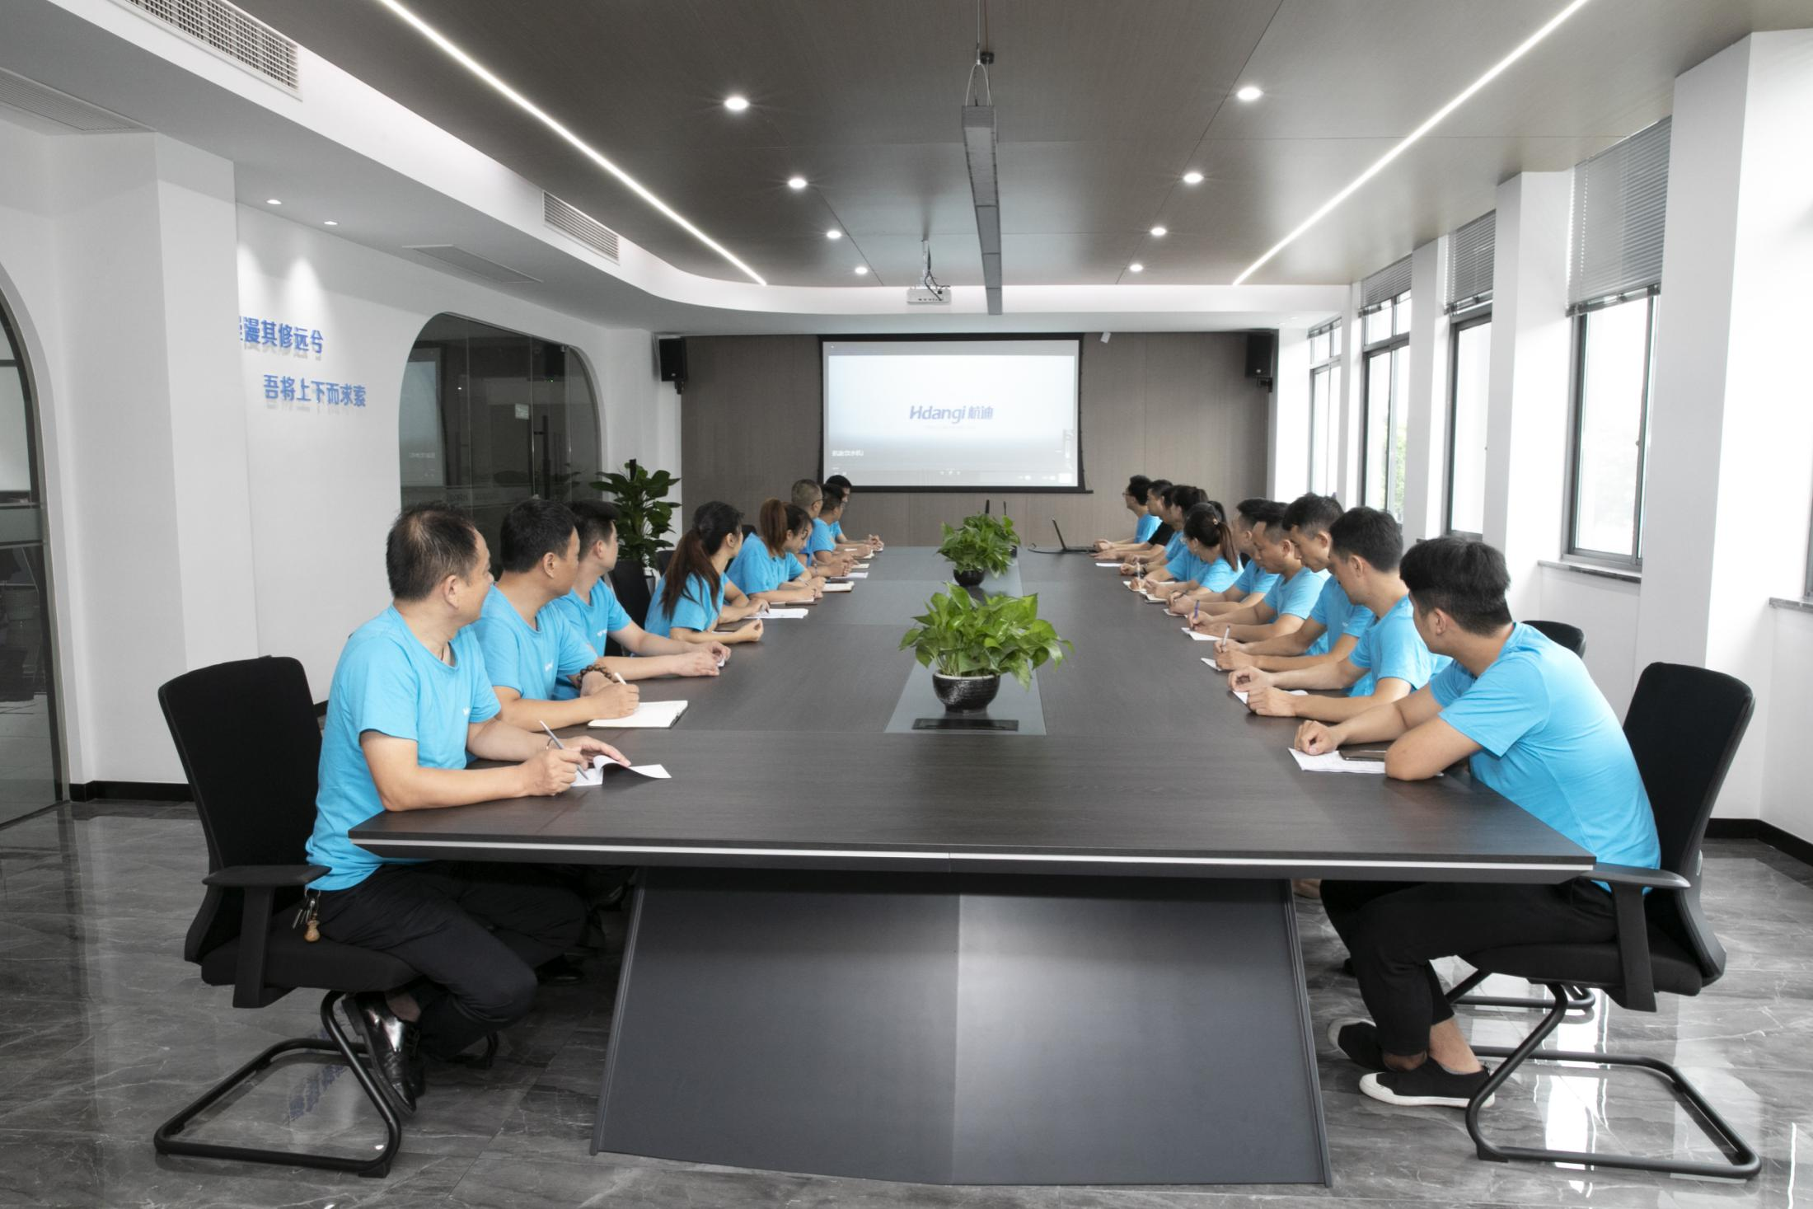

**Figure 2 Product quality training activities**

**In order to firmly establish the integrity awareness of all employees, the company formulates the quality integrity education and training plan of the year at the beginning of each year. Implement three-level quality and integrity education and training. Education at the first level is organized by the company. In accordance with the requirements of the company, the head of each department shall prepare education and training plans and contents, and conscientiously organize the education and training of the subordinates. Each workshop director is responsible for the integrity publicity and education work of the team leader and employees. The company implements quality and integrity education for employees through special training, Posting or communicating in written words, exchanging experience of advanced employees of quality and integrity, using morning meetings or pre-work meetings, using pictures and other ways. The company gives certain rewards to those who have excellent performance in quality and integrity education and training, and also gives certain rewards to those who have taken the lead or made outstanding achievements in their jobs after training. At the same time, the company promotes and promotes experience among employees. Employees who do not participate in quality integrity education and training on time or fail to pass the training and assessment will be given certain penalties.**

**3. Quality regulations and responsibility system**

**By collecting laws and regulations and other standards and requirements, the company formulates relevant internal standards, so that the products meet the requirements of national laws and regulations and national and industry standards (some product indicators exceed external requirements), and practice social responsibility from the product technology. At the same time, the company has formulated the "Quality reward and punishment Management Standards" and "Quality Assessment Management Measures", etc., to punish product quality problems and follow the principle of not letting go of quality accidents.**

**Table 2 Quality standards and other relevant laws complied by Ningbo Hangdi Electrical Technology Co., LTD**

| **class** | **Inner volume** |
| --- | --- |
| **Employee rights and interests**  **Social responsibility** | **"Labor Law", "Trade Union Law", "Consumer Rights and Interests Protection Law", "Environmental Protection Law", "Safety production Law", "Occupational Disease Prevention and Control Law", ISO9001:2015, ISO45001:2018 standard, ISO14001:2015 standard, etc** |
| **Product standard**  **Implementation and formulation** | **Mainly implement QB/T 4098 "Quick heating Water dispensers for household and similar purposes" and customer standards.** |

**The company has formulated the "Internal Audit Procedure" and "Management Review Procedure", and trained the internal audit team. In order to ensure the effectiveness and continuous improvement of the system operation, arrange internal audit, process audit and quality audit. For the nonconformities found in the audit, the responsible department shall analyze the causes, formulate corrective or preventive measures, implement rectification, verify the rectification effect, and finally form an internal audit report, making suggestions on the system rectification and prevention of nonconformities. And as an important input of management review, report to top management.**

**The company has formulated the "Nonconforming Products Control Procedure", "Inspection and test control Procedure", "Corrective and preventive measures control Procedure", and has carried out strict control over nonconforming products. All the company's products are inspected online, and can be passed into the next process or factory. Any unqualified products have clear identification, record, isolation and treatment requirements, and all kinds of unqualified products must be re-inspected and qualified after rework and repair before entering the next process.**

**At the same time, according to the Inspection and Test Control Procedure, all the nonconformities will be recorded in detail, and after statistical analysis by special personnel, the responsible unit will formulate corrective and preventive measures according to the Control Procedure for Corrective and preventive measures and carry out rectification, and the problem item can be closed only after evaluating the effectiveness of corrective and preventive measures.**

**In addition, the company has also formulated the "Quality Manual", "Supplier quality Assurance Manual", "Employee quality education management Measures" and other systems to accountability and education for quality problems, and in daily research and development, production operations, emphasis on systematization, through the quality control circle, continuous improvement and other activities and quality tools to fully apply the PDCA cycle, continuous improvement, continuous improvement, etc. Strive for excellence.**

**(3) Quality and safety risk management**

**The company formulates the routine product production and operation control process, so that each link is strictly controlled and strictly checked to ensure that each production process meets the relevant requirements and ensures the quality of the final product. The company also uses the three-inspection system, that is, self-inspection, random inspection, quality supervision team to strictly control product quality.**

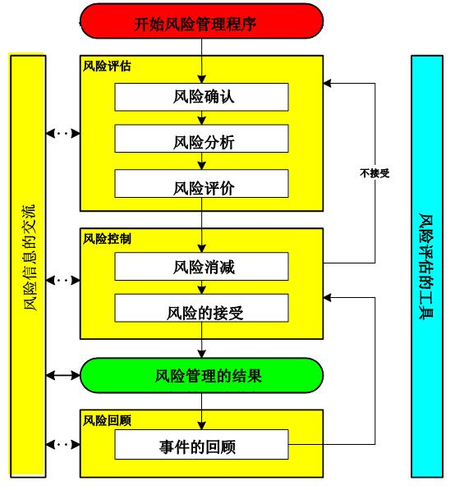

**Figure 4 Risk management program**

**The company has formulated an emergency plan for quality and safety, and established an emergency leading group with the general manager as the group leader, the management representative, the deputy general manager as the deputy group leader, and the members of the Quality control department, Purchasing department, health management Department, sales department, Finance department and General manager. It also clarified the responsibilities of the emergency leading group and relevant departments.**

**Fourth, quality and integrity management**

**(1) Quality commitment**

**1. Be honest and law-abiding**

**The senior leaders follow the management philosophy of "operation according to law and integrity", strictly abide by the Company Law, the Economic Law, the Contract Law, the Product Quality Law, the Production Safety Law, the Environmental Protection Law, the Labor Law and the relevant laws and regulations of the metal products industry, strengthen the legal knowledge training of employees, and cooperate with the government departments to carry out legal education activities. Encourage and commend the "positive energy" of employees, so that the style of integrity and law-abiding deeply in the consciousness and behavior of all employees of the company. The active default rate of the company's contracts is zero, it never defaults on bank loans, and overdue accounts receivable are reduced to a reasonable range. The company's senior and middle-level leaders have no record of violating laws and discipline, and the number of violations of employees is zero, establishing a good image of credit ethics in customers, users, the public and society.**

**2, to meet customer needs**

**The company attaches great importance to technology research and development, more than 6 new products are launched on the market every year, actively listen to customers' opinions and suggestions on function, quality, configuration, etc., carry out product improvement and innovation activities to meet customers' needs for products and delivery. In terms of product quality, the company strictly implements the ISO9000 quality management system, and ensures product quality and safety by carrying out activities such as technical research, quality improvement and QC team.**

**(2) Operation and management**

**1, product design integrity management**

**The company's product design and research and development in strict accordance with the "design and development control procedures", from the research and development project, process of all kinds of activity records, research and development process summary, management evaluation and control of research and development related to the entire process.**

**2. Integrity management of raw materials or parts procurement**

**According to the risk degree of the material to the product quality, the material is divided into three categories: A, B and C. For Class A material suppliers, in addition to meeting the statutory qualifications, they must also conduct regular on-site audits. For the supplier of Class B materials, the enterprise should first carry out risk analysis on the material, and decide whether to conduct on-site audit according to the quality of the material provided by the supplier. For suppliers of Class C materials, only their qualifications are generally considered for audit. After the qualification audit and on-site audit of the material supplier, the material supplier who agrees to purchase shall establish quality files if it meets the requirements. Full inspection of the raw materials purchased, and any raw materials that do not meet the prescribed standards shall not be put into storage for use.**

**In terms of raw materials and parts procurement, the relevant qualifications of suppliers are strictly reviewed. When purchasing raw materials and parts, we can use standard parts to purchase and use standard parts. For special processing, the use effect should be fully verified to ensure that it meets the requirements of our company. All raw materials must be strictly tested before use to ensure that they meet the product process requirements.**

**3. Integrity management of production process**

**The health management department of the company is responsible for the production management of various types of products. Various production management systems, working standards, post operating procedures and various process procedures, management procedures and standard operating procedures have been formulated and gradually improved. The use of workshop centralized training and before and after work will be a comprehensive post skills training for the operators of each position, certificate, and use a variety of ways to supervise and assess, enhance the quality awareness of employees, improve the level of operation, in the production process, managers at all levels strictly perform management responsibilities, timely inspection, timely correction of errors, to ensure the stability of production order.**

**Review the raw materials, auxiliary materials and packaging materials required for production before feeding, ensure the quality of intermediate products and finished products, strictly implement the "three No principles" of "no production of unqualified products, no acceptance of unqualified products, and no circulation of unqualified products", set up quality control points in key processes, urge employees to do a good job of self-inspection and mutual inspection, implement monitoring and verification procedures, and strictly manage batch records. To receive, issue and check the unity. Carry out material balance for each production step, ensure that the input of materials and the output quantity of products are consistent with the process requirements, and confirm that there are no potential quality hazards and meet the registration requirements.**

**Production records shall be reviewed, printed and kept by the Health Management Department. Employees must fill in production records in time as required, so that the handwriting is clear, the content is true, the data is complete, and the operator and the reviewer sign for confirmation. After the end of each batch of production, the workshop technician will summarize and review the records, and timely submit them to the R & D Department. After the R & D Department and quality Control Department review and verify that they are correct, they will be sorted out and filed according to the batch number and managed by special personnel.**

**According to the characteristics of the industry and the actual situation, the company strengthens the information construction level of the product design process, and realizes the visual design by applying 3D design technology. And tap the internal potential, give full play to the strength of technical backbone personnel, carry out the continuous transformation of the existing production process and equipment or scientific and technological innovation work, set up a technical research team to carry out technical research on weak links; Before the production staff to go through training and assessment, establish training files for all staff, through centralized training, pre-shift meeting training, "transmission, help, with", visual and other ways of training, strengthen their work skills and quality awareness. Production staff strictly abide by the workshop discipline.**

**The company implements the unit and fine production organization model to shorten the production and delivery cycle, quickly adapt to the ups and downs of the variety and quantity of market orders, and meet customer needs on the basis of reducing inventory. According to the production process characteristics of screw and barrel products, complete sets of production equipment and process equipment are equipped in a manufacturing unit to achieve a process production. Through the application of the unit production mode, the quality control process has been effectively controlled, and each manufacturing unit has a reasonable quality control process and quality control standards, which has stabilized and improved the pass rate of products to customers.**

**Through the implementation of unit production, product quality has been further recognized, sales have steadily improved, and to a large extent, the after-sales quality problem has been solved, the workload of after-sales service staff has been reduced, and the after-sales service work arrangement is more flexible.**

**(3) Marketing management**

**The company segments the market according to strategic requirements to improve the effectiveness and targeting of resources and operations. The company divides customers into direct customers and indirect customers. Determine customer needs and expectations for different types of customers, determine appropriate methods according to their needs and expectations, establish corresponding systems and teams, establish various channels and methods, and conduct targeted understanding of customer needs and expectations.**

**Through Canton Fair, China Fair, international exhibition, industry conference, industry standard committee, public media, Internet, external agencies and other channels, questionnaire survey, face-to-face or telephone interview, observation inquiry, external commission and other methods, to understand the needs and expectations of customers.**

**Various departments of the company regularly collect customer information, classify and summarize the customer demand information determined after analysis according to different market segments, form the demand and expectation database of different customer groups, and summarize the overall demand characteristics of different market segments for product planning, product development and design, process control and other decisions.**

**The company establishes a "customer demand-oriented" service concept, requiring business personnel to be enthusiastic and thoughtful for any customer, whether he places an order or not, and try to meet all their reasonable needs. Established the "Customer Satisfaction survey and measurement Procedure", "Customer Service Process", "Customer Contract review system", etc., from all aspects to increase the skills and quality of business personnel, improve the customer transaction rate.**

**The company has established a customer return visit system, attached a customer feedback card to each product, and adopted a voluntary form to record customer contact phone number, product model, order time and other relevant information, receive customer feedback and improvement suggestions, and improve customer satisfaction.**

**5. Basis of quality management**

**(1) Standard management**

**The company will be enterprise standardization throughout the whole process of production, from raw and auxiliary materials, packaging materials procurement, semi-finished products, finished product inspection and other links, have formulated relevant standards. Thus, the whole production process of the product from the raw and auxiliary materials into the factory to the finished product is in the standardized management, which lays a good foundation for stable product quality and improve the management level of the enterprise.**

**(2) Measurement management**

**The company strictly implements the Metrology Law of the People's Republic of China and other documents and regulations, and has established a set of management documents and control methods from raw material procurement, process management, production equipment, inspection equipment, process inspection, finished product inspection and other links. There are full-time and part-time metrology personnel responsible for the company's in-use metrology equipment management, equipment and regular inspection work, pay attention to the professional training of metrology management personnel, for the company's standardization of metrology management provides a strong guarantee.**

**In order to ensure product quality, strict process control in the product production process, strengthen the measurement management of raw and auxiliary materials in the production process, and ensure the normal operation of measuring equipment and the accuracy of measurement.**

**The purchasing, import and export of measuring instruments shall be carried out in strict accordance with the approval plan and management procedures. The warehouse shall have special personnel to take care of the measuring instruments, establish a ledger and register procedures, and the measuring instruments shall pass the verification before being put into use with the verification certificate. Verify the measuring instruments in use strictly according to the cycle, strengthen on-site inspection and supervision, master their use, and deal with problems in time; Put forward rectification opinions on the existing problem departments, take active and effective measures to rectify, and lay a solid measurement foundation for the production of high-quality products.**

**(3) Certification management**

**At present, the company has passed ISO9001 quality management system certification, and introduced ISO45001:2018 standard, ISO14001:2015 standard, excellent performance and other management models, and is ready to carry out "Made in Zhejiang" brand certification. The company will strictly implement the international quality management system, so that the quality of enterprise products is effectively guaranteed, so that the enterprise "quality first, customer first; Green environmental protection, continuous improvement "quality policy has been successfully implemented. Since the establishment of the factory, the company has never had major quality complaints, and in the random inspections of quality research and development departments at all levels over the years, the pass rate has reached 100%.**

**(4) Inspection and testing management**

**The company through the inspection and test of incoming goods to ensure that the supplies provided by suppliers meet the requirements of the regulations. The quality control department is responsible for the preparation of incoming inspection and test procedures, and the sampling inspection of incoming materials; Purchasing department is responsible for nonconformity**

**Materials, materials warehouse is responsible for receiving the quantity, name and weight of materials.**

**In order to ensure that all products in the production process have passed the required inspection before entering the next process, the company has formulated the "nonconforming product control Procedure" and "Shipment inspection System" to carry out strict process inspection and testing. The quality control department is responsible for the formulation of process and final inspection and test procedures, the establishment of final inspection points, and the organization of process inspection; The quality inspector is responsible for the inspection of inspection points, semi-finished products and finished products; The operators of each health management department are responsible for the self-inspection work.**

**Table 3 Testing equipment adopted by the company (part)**

|  |  |  |  |  |
| --- | --- | --- | --- | --- |
| **Serial number** | **Device name** | **Set number** | **advancement** | **remark** |
| **1** | **High-pressure instrument** | **1** | **Domestic leading** |  |
| **2** | **detector** | **6** | **Domestic leading** |  |
| **3** | **Leak detector** | **1** | **Domestic leading** |  |
| **4** | **Ground resistance tester** | **1** | **Domestic leading** |  |
| **5** | **colorimeter** | **1** | **Domestic leading** |  |
| **6** | **Water system** | **1** | **Domestic leading** |  |
| **7** | **Water dispenser six station type laboratory** | **1** | **Domestic leading** |  |
| **8** | **Water cooler test line** | **1** | **Domestic leading** |  |
| **9** | **Vibrating disk terminal** | **1** | **Domestic leading** |  |
| **10** | **Intelligent tea bar machine workbench** | **1** | **Domestic leading** |  |

**6. Product quality responsibility**

**(1) Product quality level**

**In order to better meet consumer demand preferences, Ningbo Hangdi Electrical Technology Co., Ltd. continues to improve technology research and development strength, product quality and service level, in the past three years, the timely delivery rate of the company's products has remained at a higher level of more than 97% of the industry, and shows a steady upward trend. Product delivery accuracy and customer complaint handling are maintained at 100% level.**

**Table 4 Main product and service performance**

|  |  |  |  |  |  |
| --- | --- | --- | --- | --- | --- |
| **Index item** | | **unit** | **2021** | **2022** | **2023** |
| **On-time delivery rate** | home | **%** | **95.2** | **96.7** | **97** |
| **Product accuracy** | home | **%** | **100** | **100** | **100** |
| **Timely handling rate of customer complaints** | home | **%** | **100** | **100** | **100** |
| **Customer complaint handled satisfactorily** | home | **%** | **100** | **100** | **100** |
| **Product return rate** | home | **%** | **0.1** | **0.1** | **0.1** |

**(2) The results of key performance indicators of major products and services compared with domestic and international levels**

**In terms of product performance, the company continues to carry out product technology research and development innovation, so that the company's relevant technical indicators can meet and exceed the national standard requirements to reach the international standard.**

**(3) the characteristics and innovative achievements of the main products and services**

**In terms of product and service innovation, in addition to the annual development of new products, while actively strengthening product technology innovation. Through independent research and development mode, the company has also obtained an intelligent mobile water outlet tea bar machine, a mini desktop water dispenser, a quick hot water dispenser, a water dispenser based on Internet voice intelligence, a folding tea bar machine, an air fryer easy to clean, intelligent water dispenser, intelligent tea bar machine (vertical). As of December 2021, it has accumulated 13 valid patents, including 1 invention patent and 9 utility model patents.**

**Table 5 Examples of patents granted by the Company (partial)**

|  |  |  |  |  |  |
| --- | --- | --- | --- | --- | --- |
| **Patent number** | **Patent type** | **Patent number** | **Patent name** | **Application time** | **Authorization time** |
| **IP01** | **Invention patent** | **ZL 201610322271.8** | **That is, the electric heater control mechanism of the hot water dispenser** | **2016/5/16** | **2019/2/15** |
| **IP02** | **Utility model** | **ZL 201922273744.1** | **A lifting type hidden tea bar machine** | **2019/12/17** | **2020/11/10** |
| **IP03** | **Utility model** | **ZL 202120549020.X** | **The invention relates to an intelligent mobile water tea bar machine** | **2021.03.17** | **2021/12/24** |
| **IP04** | **Utility model** | **ZL 202120549035.6** | **A mini table-top water dispenser** | **2021.03.17** | **2021/12/7** |
| **IP05** | **Utility model** | **ZL 202120549046.4** | **The utility model relates to a tea bar machine with a tissue box structure** | **2021.03.17** | **2021/12/7** |
| **IP06** | **Utility model** | **ZL 202120549715.8** | **The utility model relates to an underlying fast heating water dispenser** | **2021.03.17** | **2021/12/7** |
| **IP07** | **Utility model** | **ZL 202120549732.1** | **An intelligent water dispenser based on Internet voice** | **2021.03.17** | **2021/12/7** |
| **IP08** | **Utility model** | **ZL 202120856805.1** | **A folding tea bar machine** | **2021.04.24** | **2021/11/26** |
| **IP09** | **Utility model** | **ZL 202120699154.X** | **An air fryer for easy cleaning** | **2021.04.07** | **2021/12/24** |
| **IP10** | **Appearance design** | **ZL 202130385034.8** | **Folding tea bar machine** | **2021.06.22** | **2021/12/3** |
| **IP11** | **Appearance design** | **ZL 202130385054.5** | **Vertical tea bar machine** | **2021.06.22** | **2021.09.28** |
| **IP12** | **Appearance design** | **ZL 202130385056.4** | **Intelligent vertical tea bar machine** | **2021.06.22** | **2021/10/15** |
| **IP13** | **Appearance design** | **ZL 202130777839.7** | **Smart water dispenser** | **2021.12.24** | **2022/5/17** |
| **IP14** | **Appearance design** | **ZL 202130778300.3** | **Vertical tea bar machine** | **2021.12.24** | **2022/5/17** |
| **IP15** | **Appearance design** | **ZL 202230022064.7** | **Intelligent Tea Bar Machine (vertical)** | **2022.01.13** | **2022/4/26** |
| **IP16** | **Appearance design** | **ZL 202230149430.5** | **Air Fryer (HD-ZG012)** | **2022.03.22** | **2022/7/26** |
| **IP17** | **Appearance design** | **ZL 202230149479.0** | **Air Fryer (HD-ZG015)** | **2022.03.22** | **2022-07-26** |
| **IP18** | **Appearance design** | **ZL 202230149429.2** | **Air Fryer (HD-ZG013)** | **2022.03.22** | **2022-07-26** |
| **IP19** | **Appearance design** | **ZL 202230243328.1** | **Water heating blanket main engine shell** | **2022/4/24** | **2022/8/9** |
| **IP20** | **Utility model** | **ZL 202222362031.4** | **A see-through air fryer for easy observation of ingredients** | **2022/9/6** | **2022/12/14** |
| **IP21** | **Appearance design** | **ZL 202230627270.0** | **Heating blanket Machine (2)** | **2022/9/22** | **2022/12/16** |
| **IP22** | **Appearance design** | **ZL 202230464349.6** | **Water heating blanket host machine** | **2022/7/20** | **2022/12/9** |

**Table 6 Other awards received in the past three years**

|  |  |  |  |
| --- | --- | --- | --- |
| **Award name** | **Awarding department** | **Award time** | **Award description** |
| National high-tech enterprises | Ningbo Science and Technology Bureau, Finance Bureau, Tax Bureau | **2023** |  |
| Ningbo enterprise engineering technology center | Ningbo Science and Technology Bureau | **2022** |  |
| Ningbo innovative small and medium-sized enterprises | Ningbo Economic and Information Bureau | **2022** |  |

**(4) Product after-sale liability**

**The company establishes and implements customer complaint handling procedures to ensure timely and effective handling of customer complaints. Customer complaints are handled by full-time staff, each complaint work order should be closely monitored, according to the differences in the type and degree of customer complaints, customer-centric and pay attention to collecting and solving customer feedback, and take necessary corrective/preventive measures to prevent the recurrence of similar problems. Follow up the complaint handling process by telephone return visit to understand customer satisfaction.**

**At the same time, the company's sales department and quality control department regularly monitor customer complaint information, collect and analyze the repeated problems in the market that affect customer satisfaction and product experience, and form reports. Regularly organize internal departments to hold product quality meetings. Set up a quality control circle, cross-departmental product quality improvement team, and link upstream suppliers and relevant partners to improve major product quality problems, eliminate quality risks, and improve product quality satisfaction.**

**(5) Corporate social responsibility**

**The company is actively fulfilling its public responsibility, civic duty and ethical code while continuing to develop. In terms of public responsibility, the company takes environmental protection and energy consumption reduction as the focus of work, actively innovates and continuously improves, and has achieved remarkable results; In terms of moral behavior, the company puts forward the talent concept of "training and growth", and takes into account the interests of customers, employees, the government and other relevant parties; In terms of public welfare support, senior leaders take the lead, and employees actively participate in and actively return to society.**

**1. Public responsibility**

**Ningbo Hangdi Electrical Technology Co., Ltd. attaches great importance to the identification and management of important issues of social responsibility, uses the principle of stakeholder participation, combines with the upgrading of corporate strategy and daily business operation management, defines the substantive issues of corporate social responsibility from two dimensions of the company and stakeholders, and provides a basis for continuous improvement of social responsibility management. Through matrix analysis, the company identified that compliance, environmental protection, production safety, public health, etc. are the company's focus.**

**(1) Identify the impact of products, services and operations on society**

**The company's products, services and operations are mainly related to quality and safety, environmental protection, energy conservation, comprehensive utilization of resources, safe production, public health and other aspects of the impact. Among them, environmental protection mainly includes noise, waste gas, waste water, solid waste pollution and so on. The comprehensive utilization of resources mainly has safety production risks, such as injuries caused by various operating equipment and fire; Energy saving mainly includes electricity, gas, water, etc. Public health mainly includes domestic garbage, domestic sewage and so on.**

**Table 7 Measures of the social impact of products, services and operations**

| **item** | **Existing control measures** |
| --- | --- |
| **Quality safety** | **The quality management of the company strictly abides by national regulations and standards, implements and passes the ISO9001 quality management system certification, constantly improves the quality management process, and controls product quality from many aspects such as quality management, quality inspection and test, measurement and testing. A strict quality control system has been formed in the process of raw materials entering the factory, process inspection and finished products leaving the factory. In addition, the company has formed a perfect process research and development and application process in terms of product production technology, and can constantly update and improve the process flow in line with the requirements of large-scale production according to the needs of product design and processing standards. The formation of scientific and complete process and technical standards to ensure the strict implementation of the production process, so as to continuously improve product quality, grade and standards, and the development of industry-leading enterprise standards and technological processes, so that every link of the production process has rules to follow.** |
| **Environmental protection** | **Reduce all kinds of pollution by installing waste gas treatment equipment, sewage treatment stations and sound insulation and shock absorption facilities. The company has the "Urban drainage Permit", the wastewater is discharged after isolation treatment, the discharge water is tested and analyzed by the third party every year, and the indicators meet the relevant national standards. For a small part of the exhaust gas generated in the production process of some workshops, it is uniformly collected and discharged by qualified testing institutions every year, and the output of the exhaust gas Test Report is in line with the relevant national standards. The company organizes the identification of solid waste from various departments every year, classifies it according to relevant national laws and regulations and standards, recyles and reuses recyclable solid waste, and distributes non-recyclable and hazardous waste uniformly to institutions with Hazardous Waste Operation License for scientific treatment. The company tries to choose high-efficiency and low-noise equipment. After environmental assessment by professional organizations, the company has little impact on the surrounding acoustic environment. The results of the "Factory Boundary Noise Detection Report" tested by qualified companies meet the relevant national standards.** |
| **Energy saving** | **In full combination with the network and traditional publicity means, we publicize the environmental protection of employees by introducing environmental tips in internal journals and publicity columns, and launching environmental protection proposals, and vigorously advocate employees to pay attention to diligence and frugality. Starting from daily work and life, we should save electricity, paper and water, and improve each employee's awareness of energy conservation and emission reduction. The requirements of water saving, electricity saving and paper saving are institutionalized, and the management requirements of saving are clearly stipulated. In addition to training and publicity to improve the awareness of energy saving and emission reduction of employees, special personnel are also arranged to carry out inspection and inspection in the company to ensure the implementation. Air compressor adopts frequency conversion motor, which can save electricity.** |
| **Comprehensive utilization of resources** |
| **Safe production** | **The company has a production safety management team, organizes special personnel to collect laws, regulations, standards and norms, strengthens the comprehensive management of occupational disease prevention, fire safety, electrical safety, equipment safety, chemical safety, labor protection supplies and other aspects, designates special personnel to regularly investigate and control hidden dangers, establishes emergency agencies and teams, optimizes emergency plans, and equips with various emergency materials. Annual fire emergency drill.** |
| **Public health** | **In the treatment of domestic sewage, the General manager Office is responsible for inspecting the rain pollution Wells to ensure the diversion of rain pollution. The domestic sewage in the canteen is filtered and isolated into the sewage pipe, and the canteen is responsible for cleaning the filtered residue in time and putting it into the designated point of domestic garbage. The General Manager Office shall cooperate with the local environmental protection department to test the company's sewage discharge every year to ensure that the company's sewage discharge indicators meet the national standards. In response to the problem of fume in the canteen, the company has equipped fume purification devices, which are regularly tested by qualified testing institutions, and the indicators are in line with relevant national standards.** |

**(2) Identify future worries and seek sustainable development**

**The company takes the initiative to collect relevant laws and regulations based on activities, products and services, and converts them into internal control procedures, which are controlled according to procedural requirements to eliminate public concerns.**

**Table 8 Prediction and response to public and environmental concerns**

| **Public concern** | **cause** | **Coping measures** |
| --- | --- | --- |
| **Quality safety** | **There may be safety hazards in the aspects of raw material composition, product design and manufacturing, and customer use** | **Strictly implement international advanced standards such as ISO9001, and follow up new standards in time; To strengthen the control of product safety in all aspects such as raw material procurement, design and production, and finished product inspection; Strictly regulate product identification, develop detailed product instructions and provide related services to guide customers to use products correctly.** |
| **Environmental protection** | **The impact of waste water, waste gas, solid waste, noise, etc. on the environment and surrounding communities** | **Regularly identify the key processes of waste water, waste gas, solid waste, noise, etc. Establish internal and external environmental information communication channels and corresponding environmental information management procedures, collect and deal with internal and external environmental complaints; Regularly entrust relevant departments to carry out testing, and timely monitor and improve the possible problems.** |
| **Energy consumption** | **Insufficient supply of water and electricity can lead to water outages and power cuts, affecting production, employment or the local economy** | **Actively promote energy conservation and consumption reduction, and effectively control energy consumption. Strengthen the awareness of energy conservation and consumption reduction, and promote the innovation of new energy-saving technologies or processes; Adjust the energy consumption structure, rationally adjust the water and electricity consumption; Adopt new energy-saving technologies, new processes and new equipment to realize energy recycling and improve energy utilization efficiency.** |
| **Comprehensive utilization of resources** | **Irrational use of resources (raw materials, non-renewable resources)** | **Comprehensive utilization of raw materials: secondary development and utilization of surplus raw materials generated in the production process to improve the utilization rate of raw and auxiliary materials; Water resources and electricity resources: regular statistics of water and electricity consumption, as far as possible to reduce the waste of hydropower, comprehensive use of hydropower resources.** |
| **Safe production** | **Fire, employee disputes, industrial accidents and other hidden dangers** | **Establish a safety leading agency, improve the safety production management system and regulations, and carry out safety education activities regularly or irregularly; Improve the equipment management system, implement responsibilities, carry out equipment maintenance as planned, and carry out equipment technical transformation for equipment with hidden safety risks; Prepare the Emergency Rescue Plan for Work Safety Accidents, implement emergency measures for work safety, equip the whole plant area and workshop with fire fighting facilities, and accept third-party inspection regularly to ensure fire safety; According to the production safety inspection system, regularly carry out safety hidden dangers inspection, timely discover and eliminate safety hidden dangers; Implement the safety production responsibility system reward and punishment assessment, each process, work, all types of equipment to develop safety operating procedures, comprehensive prevention.** |
| **Public health** | **Household waste and solid waste will affect the health of employees and the surrounding environment** | **Adhere to the policy of "prevention first and combining prevention and treatment" in public health work; Garbage classification management, comprehensive treatment, reduce the concerns of employees and surrounding.** |

**(3) Identify key processes and performance indicators**

**The company determines the key processes, measurement methods and objectives, and adopts corresponding countermeasures and measurement methods according to the requirements of laws and regulations and mandatory standards regarding the impact of products, services and operations on quality and safety, environmental protection, energy conservation, comprehensive utilization of resources, production safety and public health.**

**Table 9 Measurement index, method and control process**

| **item** | **National and industry standards** | **Control metrics** | **Measurement method** | **Critical process** | **Responsible department** |
| --- | --- | --- | --- | --- | --- |
| **Quality safety** | **QB/T 4098 "Household and Similar Instant Water Dispensers",** **etc** | **The number of casualties caused by the use of the company's products** | **The responsible departments shall conduct periodic inspections and record them in accordance with the system documents** | **Relevant systems and standards are formulated at different stages such as** **planning, procurement, production**, and delivery, and product **quality and safety are controlled** through **incoming inspection, process inspection, and finished product inspection** | **R&D Department,** **Production Management Department**, **etc** |
| **Environmental protection** | The third-level standard of "Comprehensive Sewage Discharge Standard", the **second-level standard of "Comprehensive Discharge** Standard of **Air Pollutants",** **and the second-level standard of "Noise Emission Standard for Industrial Enterprises".** | **Wastewater discharge compliance rate**  **Exhaust emission compliance rate**  **Noise coincidence rate at plant boundary** | **The company's internal** **control** **and entrust external qualified units for testing** | **In view of environmental pollution, we strictly abide by the requirements of relevant national laws and regulations, and** **regularly entrust** **external qualified units to conduct a test on the company's noise and exhaust gas** | **General Manager's Office,** **Health Management Department**, **etc** |
| **Energy saving** | **"Energy Conservation Law of the People's Republic of China", etc** | **Comprehensive energy consumption** **of 10,000 yuan** **of total** output value  **The comprehensive energy consumption reduction rate of the total output value of 10,000 yuan** | **System management and arrange special personnel to conduct inspections and statistical analysis in the company** | **Advocate energy-saving and consumption-reducing behaviors, adopt energy-saving equipment, formulate internal control systems on the basis of complying with relevant national laws and regulations, and standardize and require employees' daily behaviors** | **All departments of the company** |
| **Comprehensive utilization of resources** | **"Law of the People's Republic of China on the Promotion of Circular Economy", etc** | **System management and arrange special personnel to conduct inspections and statistical analysis in the company** | **Advocate energy-saving and consumption-reducing behaviors, give priority to the purchase of energy-saving, water-saving, material-saving, and environmentally friendly products and recycled products, and reuse recyclable resources** | **All departments of the company** |
| **Safe production** | **"Labor Law of the People's Republic of China", "Work Safety Law of the People's Republic of China", etc** | **the number of** **major safety accidents**, etc | **Intrastat** | **Identification of potential risks for various types of work, hazard analysis and control, safety production training, supervision, education and inspection, etc., regular inspection, customer review, third-party inspection,** **etc** | **Department of Health Management, etc** |
| **Public health** | **"Cooking fume emission Standards", "Measures for the Management of Municipal Solid waste", "Measures for the Management of Hazardous waste transfer joint order", etc** | **Qualified rate of oil fume emission**  **Garbage disposal time rate** | **Transfer to an external qualification agency** | **After the canteen lampblack is produced, it is collected and purified by the range hood, and the domestic waste is cleaned and transported by the local sanitation department** | **General manager Office, etc** |

**2. Ethical behavior**

**The company adheres to the core values of "win-win cooperation, pragmatic innovation", emphasizes integrity management, dedication to society, and achieves win-win results for enterprises, employees, partners, and society. Adhere to the principle of abiding by the national laws and regulations, fully carry forward the people-oriented management, adhere to the rule of law and rule of virtue, self-discipline and heteronormality, so that the government, society, partners, and enterprise employees can keep good faith as the basic code of conduct.**

**In order to implement integrity into the hearts of all employees, the company will write relevant behaviors into the employee code of conduct in the Employee Handbook. Over the years, under the supervision of the strict integrity system and the leadership of the company's senior leaders, the company has earnestly practiced the concept of integrity, strictly fulfilled the code of ethics, achieved honesty and trustworthiness, legal business, tax payment according to law, the contract default rate is zero, never defaulted on bank loans and suppliers, and won a good social reputation; The company's senior and middle-level leaders have no record of violating laws and discipline, and have established a good image of credit ethics in customers, suppliers, the public and society.**

**(1) Clarify key processes and monitoring systems**

**A clear code of ethics based on the company's mission, vision and core values, which is regularly communicated and reinforced; Establish key processes and performance indicators to promote and monitor ethical compliance internally with customers, suppliers and partners and in corporate governance.**

**Table 10 Corporate ethical behavior monitoring system**

|  |  |  |  |  |
| --- | --- | --- | --- | --- |
| **type** | **Supervised objects** | **Authorities-in-charge** | **Measurement method** | **Measurement metrics** |
| **Within the organization** | **Company executives**  **The middle level of the company** | **Heads of departments** | **Evaluate the work performance, enterprise management, personal behavior and morality of the company's middle and senior leaders every year, and accept supervision and reporting from all employees at any time** | **Violations of discipline and law**  **Violations of major business activities** |
| **Rank-and-file employees** | **General Manager's Office, etc** | **The General Manager's Office** and **other departments shall do a good job in the education, training and assessment of employees' ethical behavior, and carry out monthly assessments, job responsibility assessments,** and **supervision and reporting of all employees** | **Uncivilized behavior**  **Work attitude**  **Violations of discipline and law** |
| **between organizations** | **vendor** | **Purchasing Department, etc** | **Strictly abide by the relevant system of supplier management and evaluation, supervise the effectiveness of the contract signed with the supplier, and** **implement "sunshine procurement".Monitor** the **timely delivery of supplier payments and evaluate the overall satisfaction of suppliers** | **Supplier complaints**  **Negative events**  **Contract performance rate**  **Timely payment rates** |
| **dealer**  **customer** | **Sales Department, etc** | **Supervise the signing of contracts with customers and the compliance of contract content and clauses, review whether the contract is performed in a timely manner, implement the "Product Quality Law", ensure product quality, and regularly measure customer satisfaction** | **Contract performance rate**  **Timely handling of** **customer complaints**  **Customer satisfaction** |
| **Outside the organization** | **government** | **Finance Department, etc** | **In accordance with the "Tax Law of the People's Republic of China" and other laws and regulations, the tax liability shall be carried out according to law** | **On-time tax rates**  **Tax rate according to law** |
| **society** | **General Manager's Office, etc** | **Protect the environment in accordance with the "Comprehensive Emission Standards for Air Pollutants", "Energy Conservation Law of the People's Republic of Chinese China", "Cleaner Production Promotion Law" and other standards** | **Environmental accidents** |

**Table 11 Control process of corporate code of Ethical conduct**

|  |  |  |
| --- | --- | --- |
| **philosophy** | | According to the core values, the interests of individuals, the overall interests of the company, the interests of **customers, the interests of suppliers, and the interests** of **dealers** are **coordinated to achieve a win-win situation, which is the ideological basis for complying with business ethics** |
| **system** | **external** | **The company adheres to** the **concept** of **customer-centric and customer satisfaction-oriented, and** **abides by the company's business norms** |
| **inside** | **We have internal rules and regulations in place to prevent unethical behavior. The "Employee Handbook" and other** norms **regulate the code of conduct for employees inside and outside. In business** **dealings** with distributors and suppliers**, the company clearly stipulates that it is not allowed to accept rebates from suppliers** |
| **Regulatory Authorities** | | **The company's general manager's office and other departments** **are responsible for receiving supervision and reports on ethical violations** |
| **Miscellaneous** | | **Control and supervise the selection of personnel from the source** |
| **The financial situation is strictly controlled, and the illegal expenses are not reported** |
| **Basic management inspection, severe punishment of illegal employees** |
| **Mobilize employees to monitor each other and allow each other to complain** |

**3. Public welfare support**

**Social welfare is an important part of enterprise development, the top management attaches great importance to public welfare activities, insists on sharing value with the society, is committed to sharing enterprise development results with the society, constantly standardizes public welfare management, combines the company's development strategy, innovates and carries out a variety of theme public welfare activities, actively advocates volunteer service, and gives back to the society with gratitude and good deeds. To pass more love and warmth to the society Ningbo Hangdi Electrical Technology Co., LTD.**

**Driven by the leadership of the company, at present, the company mainly lists industry development, local education and culture, infrastructure construction, poverty alleviation and other public welfare areas as key support and actively donate.**

**Table 12 Highlights of public welfare support**

| **Focus on public welfare**  **Areas of support** | **Specific support projects** | **Select by** | **charge**  **department** |
| --- | --- | --- | --- |
| **Industry development** | **Actively participate in** **the activities of industry organizations** | **Further consolidate the company's influence in the industry and drive the development of the industry with a responsible attitude** | **board of directors**  **General Manager's Office, etc** |
| **Lead the formulation or participate in the development of industry technical standards** |
| **Guide or** **participate in the promotion and application of new technologies in the industry** |
| **Local education and culture** | **New schools** **and other educational institutions** | **Cultivate outstanding talents, but also provide guarantee for the company to attract and cultivate follow-up talents;Fulfill corporate social responsibility and improve corporate brand image** |
| Support the **Working** **Committee** **for the Care of** **the Next Generation** |
| **Provide targeted support to students in remote or impoverished areas** |
| **Infrastructure** | **Support the** construction of **local** **urban pipe networks** **and other infrastructure** | **The sustainable operation of the enterprise is inseparable from the recognition and help of the community where it operates, and strives to benefit the community and local people's livelihood by attaching great importance to maintaining community public relations** |
| **Support the** **construction of** **new rural areas** |
| **Poverty alleviation** | **Regular** **charitable donations** | **Repay the society, in line with the company's requirements to show its corporate image and enhance its sense of corporate social responsibility** |
| **Donations for** **social emergencies** |

**In the strategic planning of the company, make special plans and special funds to carry out systematic public welfare activities.**

**(6) Quality credit record**

**Since the establishment of the factory, the company has never had major quality complaints, and in the random inspections of quality research and development departments at all levels over the years, the pass rate has reached 100%.**

**Conclusion of the report**

**Adhering to the business purpose of "developing employees, achieving customers, returning shareholders, and strengthening the country", with the business philosophy of "integrity, pragmatism, dedication, innovation", and the eternal pursuit of customer, employee, and social satisfaction, the company will complete the "zero defect" supply of small household appliances such as water dispensers, from the manufacturer to the brand's strategic upgrade, and become the world's best water dispensers supplier. To provide customers with the best service and quality, to achieve a century-old brand.**